DATA SCIENCE
Lab Record

Submitted by:
Alphons Baby
20MCA010

LAB CYCLE-1

1. Program to Print all non-Prime Numbers in an Interval

program

start = 11
end = 25
for i in range(start, end + 1):
if i > 1:
for j in range(2, i):
if (i % j == 0):
break
else:
print(i)

OUTPUT
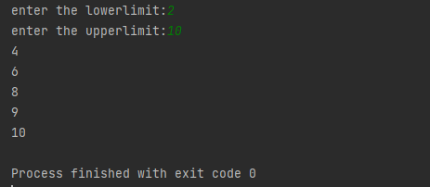
2. Program to print the first N Fibonacci numbers.
Program

def printFibonacciNumbers(n):
f1 = 0
f2 = 1
if (n < 1):
return
print(f1, end=" ")
for x in range(1, n):
print(f2, end=" ")
next = f1 + f2
f1 = f2
f2 = next

printFibonacciNumbers(7)
OUTPUT

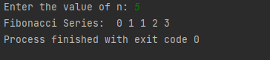
3. Given sides of a triangle, write a program to check whether given triangle is an
isosceles, equilateral or scalene.
Program

def checkTriangle(x, y, z):

if x == y == z:
print("Equilateral Triangle")

elif x == y or y == z or z == x:
print("Isosceles Triangle")

else:
print("Scalene Triangle")

x = input("enter the first side")
y = input("enter the second variable")
z = input("enter the third variable")

checkTriangle(x, y, z)
OUTPUT
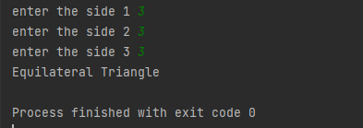
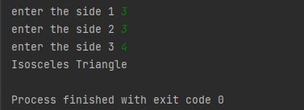
4. Program to check whether given pair of number is coprime
program

def __gcd(a, b):
if (a == 0 or b == 0): return 0
if (a == b): return a
if (a > b):
return __gcd(a - b, b)
return __gcd(a, b - a)
def coprime(a, b):
if (__gcd(a, b) == 1):
print("Co-Prime")
else:
print("Not Co-Prime")
a = 5;
b = 6
coprime(a, b)
a = 7;
b = 8
coprime(a, b)

OUTPUT

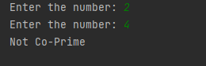
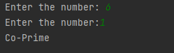
5. Program to find the roots of a quadratic equation(rounded to 2 decimal places)
Program

from math import sqrt
print("Quadratic function : (a * x^2) + b*x + c")
a = float(input("a: "))
b = float(input("b: "))
c = float(input("c: "))
r = b ** 2 - 4 * a * c
if r > 0:
num_roots = 2
x1 = (((-b) + sqrt(r)) / (2 * a))
x2 = (((-b) - sqrt(r)) / (2 * a))
print("There are 2 roots: %f and %f" % (x1, x2))
elif r == 0:
num_roots = 1
x = (-b) / 2 * a
print("There is one root: ", x)
else:
num_roots = 0
print("No roots, discriminant < 0.")
exit()

OUTPUT
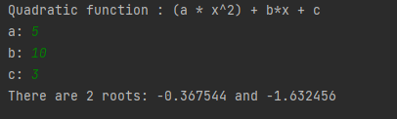
6. Program to check whether a given number is perfect number or not(sum of factors=number).
Program

n = int(input("Enter any number: "))
sum1 = 0
for i in range(1, n):
if(n % i == 0):
sum1 = sum1 + i
if (sum1 == n):
print("The number is a Perfect number!")
else:
print("The number is not a Perfect number!")
OUTPUT
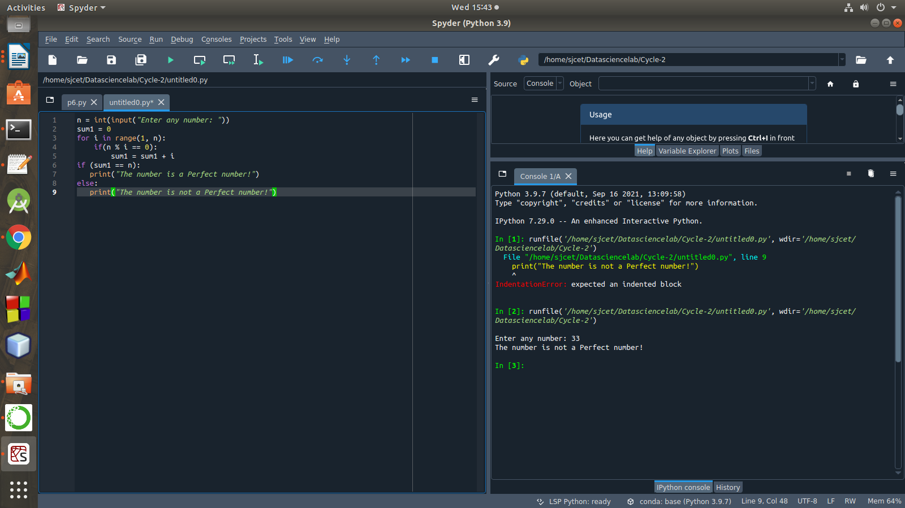

7. Program to display amstrong numbers upto 1000
Program

lower = int(input("Enter lower range: "))
upper = int(input("Enter upper range: "))

for num in range(lower, upper + 1):
sum = 0
temp = num
while temp > 0:
digit = temp % 10
sum += digit ** 3
temp //= 10
if num == sum:
print(num)
OUTPUT
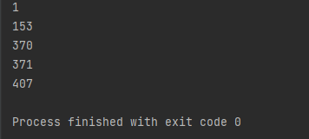
8. Store and display the days of a week as a List, Tuple, Dictionary, Set. Also demonstrate different ways to store values in each of them. Display its type also.
Program.
l = []

l.append(5)
l.append(10)
print("Adding 5 and 10 in list", l)

# Set
s = set()

s.add(5)
s.add(10)
print("Adding 5 and 10 in set", s)

# Tuple
t = tuple(l)

print("Tuple", t)
print()

# Dictionary
d = {}

d[5] = "Five"
d[10] = "Ten"
print("Dictionary", d)
OUTPUT
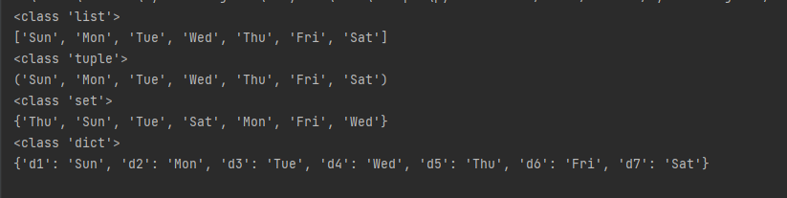
9. Write a program to add elements of given 2 lists
Program.

l = [5,6,7,8]
k=[1,2,3,4]
print("list 1 element ", l)
print("list 2 element", k)
res_list = [l[i] + k[i] for i in range(len(l))]

print("Resultant list is : " + str(res_list))
OUTPUT
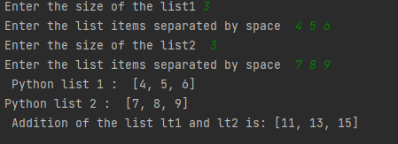
10. Write a program to find the sum of 2 matrices using nested List.
Program.

matOne = []
print("Enter Elements for First Matrix: ")
for i in range(3):
matOne.append([])
for j in range(3):
num = int(input())
matOne[i].append(num)

matTwo = []
print("Enter Elements for Second Matrix: ")
for i in range(3):
matTwo.append([])
for j in range(3):
num = int(input())
matTwo[i].append(num)

matThree = []
for i in range(3):
matThree.append([])
for j in range(3):
matThree[i].append(matOne[i][j]+matTwo[i][j])

print("\nAddition Result of Two Given Matrix is:")
for i in range(3):
for j in range(3):
print(matThree[i][j], end=" ")
print()
OUTPUT

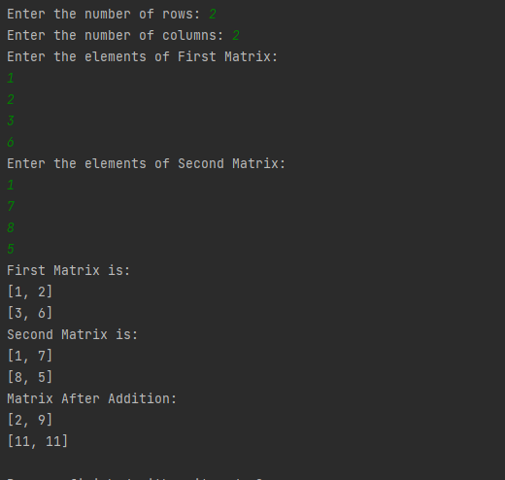
11. Write a program to perform bubble sort on a given set of elements.
Program

a=[1,2,3,4,10,3,8]
rint("Before sorting array elements are - ")
for i in a:
print(i, end = " ")
for i in range(0,len(a)):
for j in range(i+1,len(a)):
if a[j]<a[i]:
temp = a[j]
a[j]=a[i]
a[i]=temp
print("\nAfter sorting array elements are - ")
for i in a:
print(i, end = " ")
OUTPUT

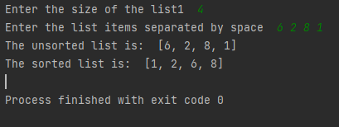

12. Program to find the count of each vowel in a string(use dictionary)
Program

string=input("Enter string:")
vowels=0
for i in string:
if(i=='a' or i=='e' or i=='i' or i=='o' or i=='u' or i=='A' or i=='E' or i=='I' or i=='O' or i=='U'):
vowels=vowels+1
print("Number of vowels are:")
print(vowels)
OUTPUT
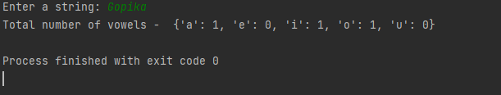
13. Write a Python program that accept a positive number and subtract from this number the sum of its digits and so on. Continues this operation until the number is positive
Program
def repeat_times(n):
s = 0
n_str = str(n)
while (n > 0):
n -= sum([int(i) for i in list(n_str)])
n_str = list(str(n))
s += 1
return s
print(repeat_times(9))
print(repeat_times(21))
OUTPUT
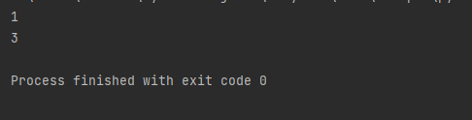
14. Write a Python program that accepts a 10 digit mobile number, and find the digits which are absent in a given mobile number
Program
def absent_digits(n):
all_nums = set([0,1,2,3,4,5,6,7,8,9])
n = set([int(i) for i in n])
n = n.symmetric_difference(all_nums)
n = sorted(n)
return n
print(absent_digits([9,8,3,2,2,0,9,7,6,3]))

OUTPUT
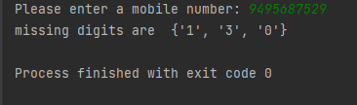

LAB CYCLE-2

LAB CYCLE 2-PART 1

1.Create a three dimensional array specifying float data type and print it.

Program

import numpy as np
arr=np.array([[[1, 2, 3], [4, 5, 6]], [[1, 2, 3], [4, 5, 6]]],dtype='f')
print(arr)

output

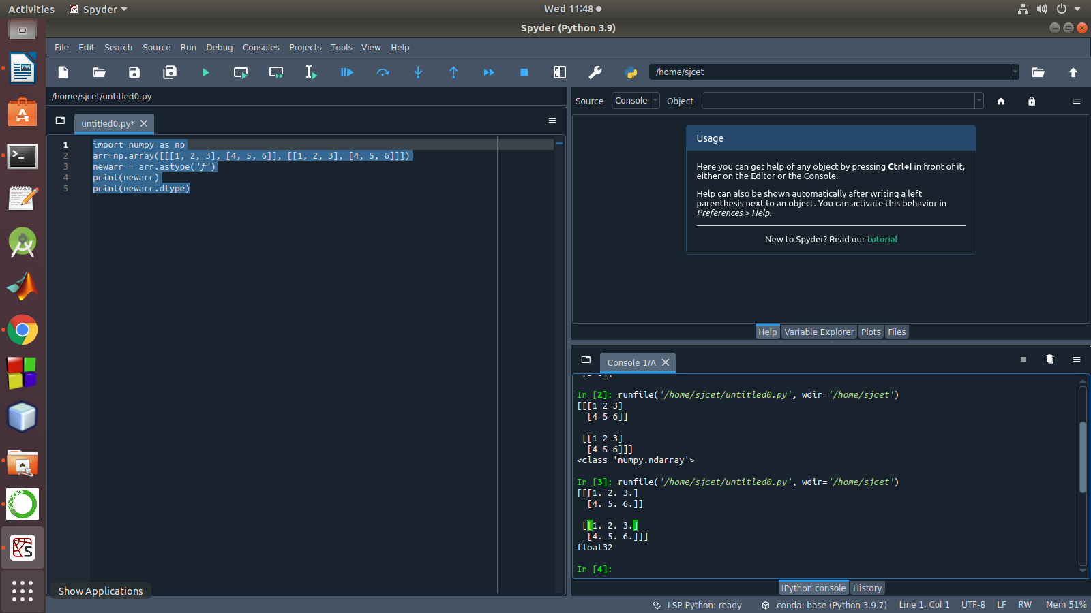

2. Create a 2 dimensional array (2X3) with elements belonging to complex data
type and print it. Also display
a. the no: of rows and columns
b. dimension of an array
c. reshape the same array to 3X2

program

import numpy as np
x = np.array([[2, 4, 6], [6.5, 8, 10]])
print(type(x))
print(x)
numOfRows = np. size(x, 0)
print(numOfRows)
numOfColumns = np. size(x, 1)
print(numOfColumns)
print("No. of dimensions: ", x.ndim)
rs=np.reshape(x, (3, 2))
print(rs)

output

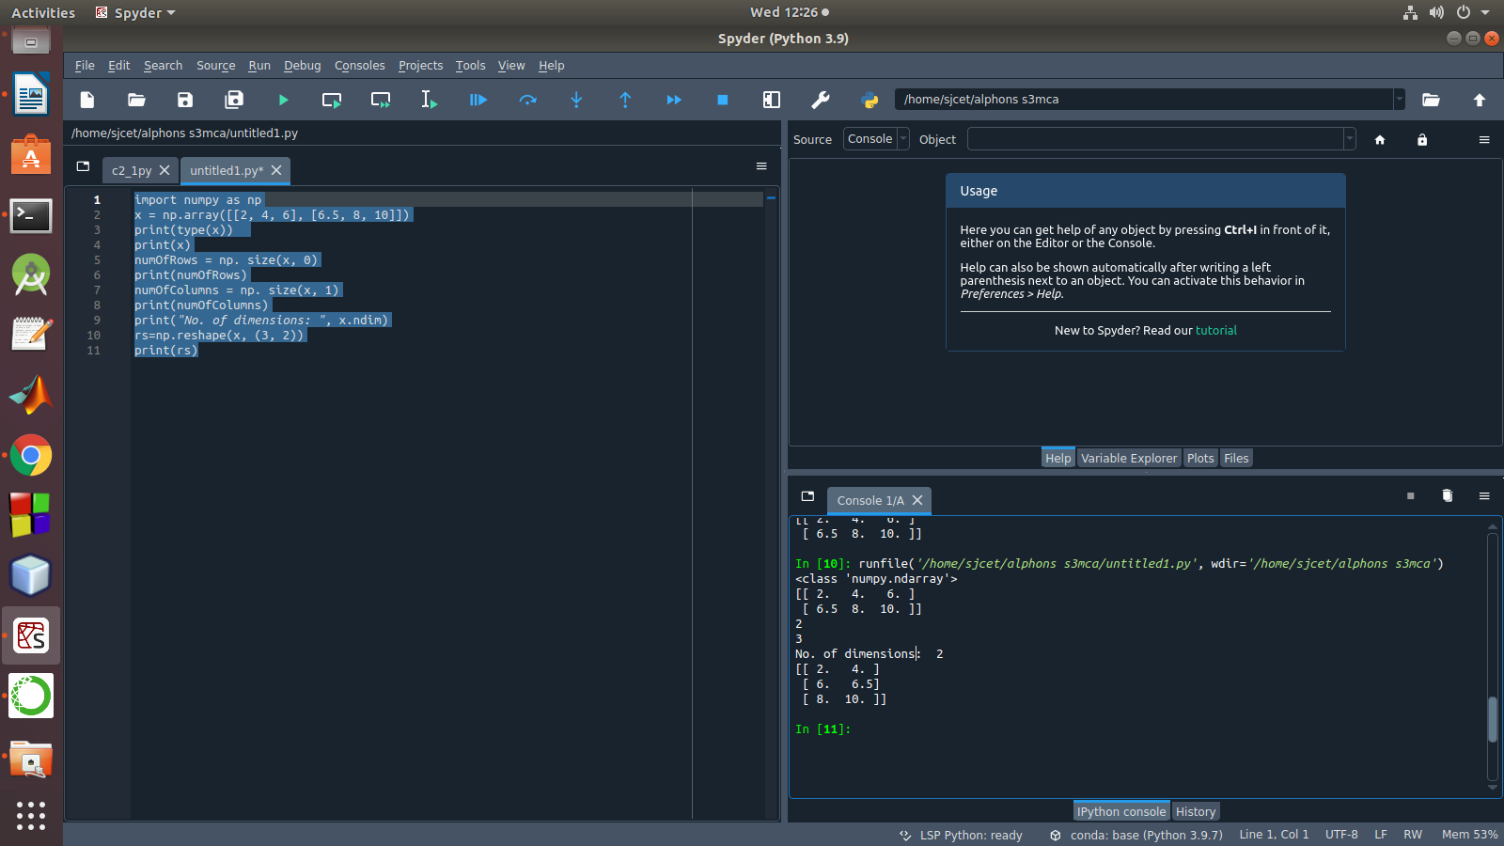
3. Familiarize with the functions to create
a) an uninitialized array
b) array with all elements as 1,
c) all elements as 0

program

import numpy as np
x=np.empty([2, 2])
print(x)
y=np.full((2, 2), 1)
print(y)
z=np.full((2, 2), 0)
print(z)

output
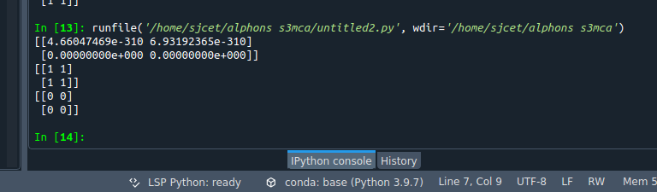

4. Create an one dimensional array using arange function containing 10 elements.
Display
a. First 4 elements
b. Last 6 elements
c. Elements from index 2 to 7

Program

import numpy as np

a = np.arange(1, 11, 1)
print(a)
first_element = a[:4]
print(first_element)
first_element1 = a[5:]
print(first_element1)
first_element2 = a[1:7]
print(first_element2)

Output
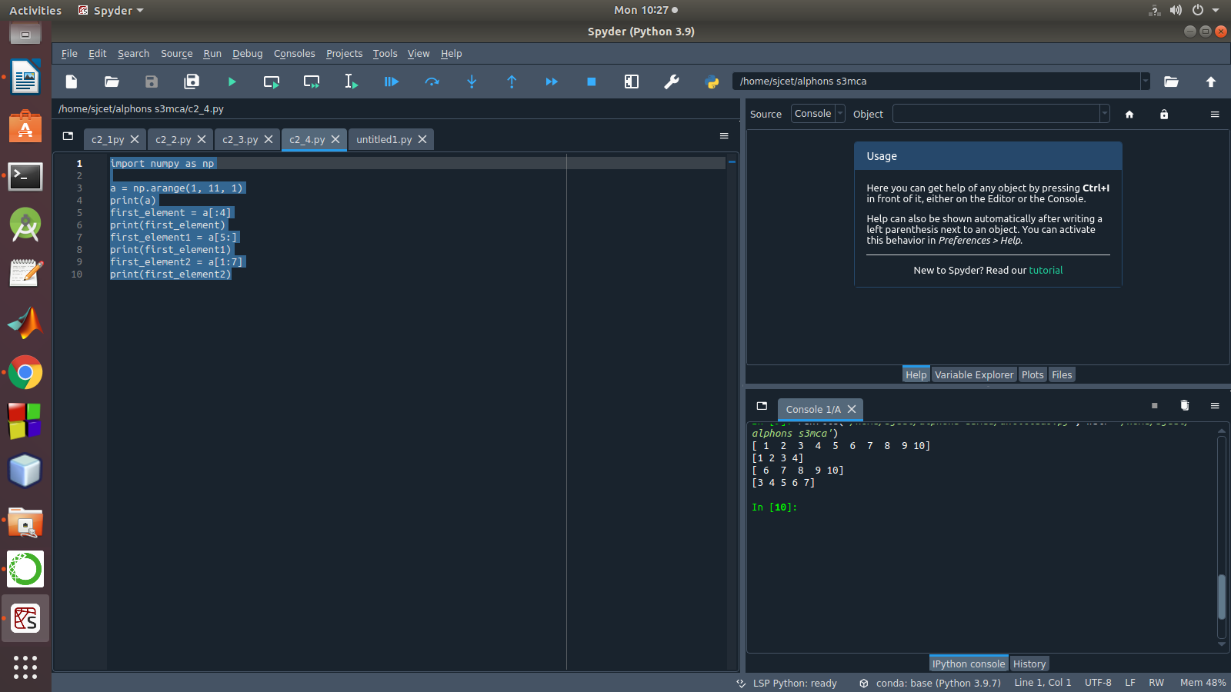

5. Create an 1D array with arange containing first 15 even numbers as elements
a. Elements from index 2 to 8 with step 2(also demonstrate the same
using slice function)
b. Last 3 elements of the array using negative index
c. Alternate elements of the array
d. Display the last 3 alternate elements

Program

mport numpy as np

a = np.arange(0, 15, 2)
print(a)
print("Elements from index 2 to 8 with step 2")
s2 = slice(2, 8, 2)
print(a[s2])

print("Last 3 elements of the array using negative index",a[-3:-1])

print("Alternate elements of the array")

ab = np.arange(1, 15, 2)
print(ab)

print("Display the last 3 alternate elements",a[-3:-1:2])
Output
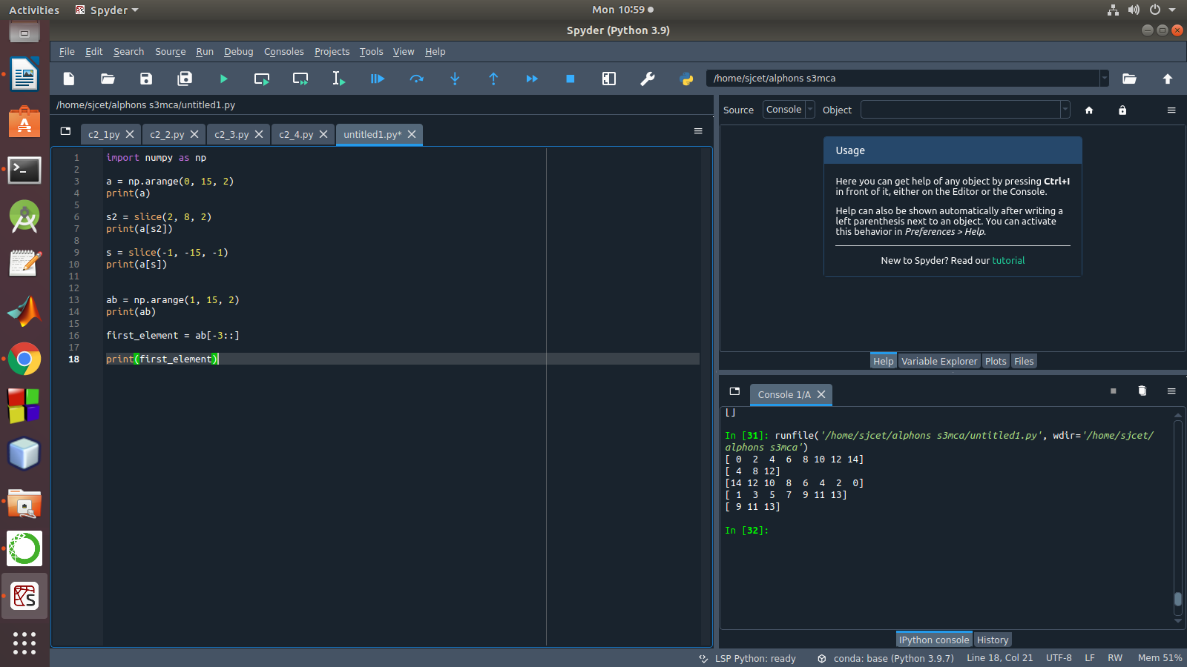

6. Create a 2 Dimensional array with 4 rows and 4 columns.
a. Display all elements excluding the first row
b. Display all elements excluding the last column
c. Display the elements of 1 st and 2 nd column in 2 nd and 3 rd row
d. Display the elements of 2 nd and 3 rd column
e. Display 2 nd and 3 rd element of 1 st row
f. Display the elements from indices 4 to 10 in descending order(use
–values)

Program

import numpy as np
x = np.array([[2, 4, 6,1], [6, 8, 10,1],[1, 2, 1,1], [1, 1, 1,1]])
print(x)
print("Display all elements excluding the first row")
print(x[1:])

print("Display all elements excluding the last column")
print(x[:, :3])

print("Display the elements of 2 nd and 3 rd column")
print(x[:, 1:3])

print("Display the elements of 1 st and 2 nd column in 2 nd and 3 rd row")

print("Display 2 nd and 3 rd element of 1 st row")
print(x[0,1])
print(x[0,2])

Output
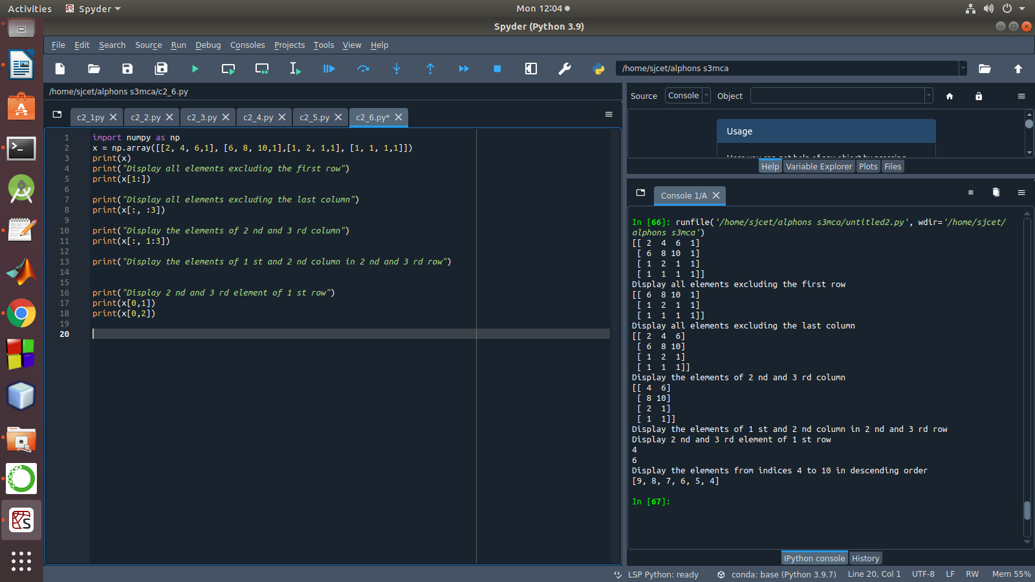

7. Create two 2D arrays using array object and
a. Add the 2 matrices and print it
b. Subtract 2 matrices
c. Multiply the individual elements of matrix
d. Divide the elements of the matrices
e. Perform matrix multiplication
f. Display transpose of the matrix
g. Sum of diagonal elements of a matrix

Program

import numpy as np

M1 = np.array([[3, 6], [14, 21]])
M2 = np.array([[9, 27], [11, 22]])
M3 = M1 + M2
print("Matrix addition")
print(M3)
M1 = np.array([[3, 6], [14, 21]])
M2 = np.array([[9, 27], [11, 22]])
M3 = M1 - M2
print("Matrix Substract")
print(M3)

M1 = np.array([[3, 6], [14, 21]])
M2 = np.array([[9, 27], [11, 22]])
M3 = M1 / M2
print("Divide the elements of the matrices")
print(M3)

M1 = np.array([[3, 6], [5, -10]])
M2 = np.array([[9, -18], [11, 22]])
M3 = M1 * M2
print("Multiply the individual elements of matrix")
print(M3)

M1 = np.array([[3, 6], [5, -10]])
M2 = np.array([[9, -18], [11, 22]])
M3 = M1.dot(M2)
print("matrix multiplication")
print(M3)

M1 = np.array([[3, 6, 9], [5, -10, 15], [4,8,12]])
M2 = M1.transpose()
print("Transpose of the matrix")
print(M2)

M1 = np.array([[3, 6, 9], [5, -10, 15], [4,8,12]])
print("Sum of diagonal elements of a matrix")
print(np.trace(M1))

Output
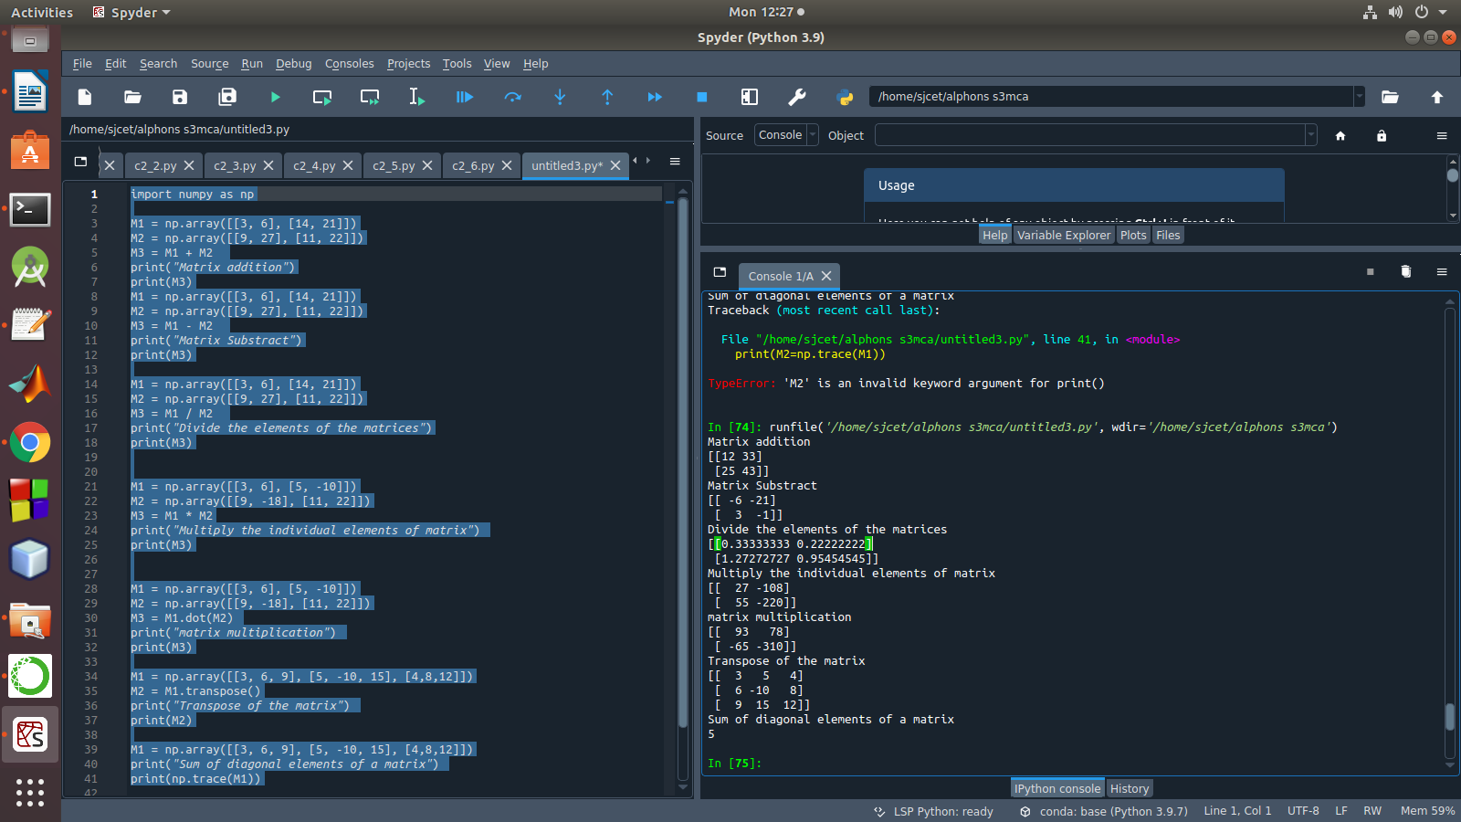

8. Demonstrate the use of insert() function in 1D and 2D array

Program

import numpy as np

arr1 = np.arange(10, 16)
print("1D ARRAY ")
print("The array is: ", arr1)

obj = 2
value = 40

arr = np.insert(arr1, obj, value, axis=None)

print("After inserting the new array is: ")
print(arr)
print("Shape of the new array is : ", np.shape(arr))

print("2D ARRAY ")
arr1 = np.array([(1, 2, 3), (4, 5, 6), (7, 8, 9), (50, 51, 52)])

print("The array is: ")
print(arr1)
print("The shape of the array is: ", np.shape(arr1))

a = np.insert(arr1, 1, [[50], [100], ], axis=0)

print("New array is : ")
print(a)
print("Shape of the array is: ", np.shape(a))

Output
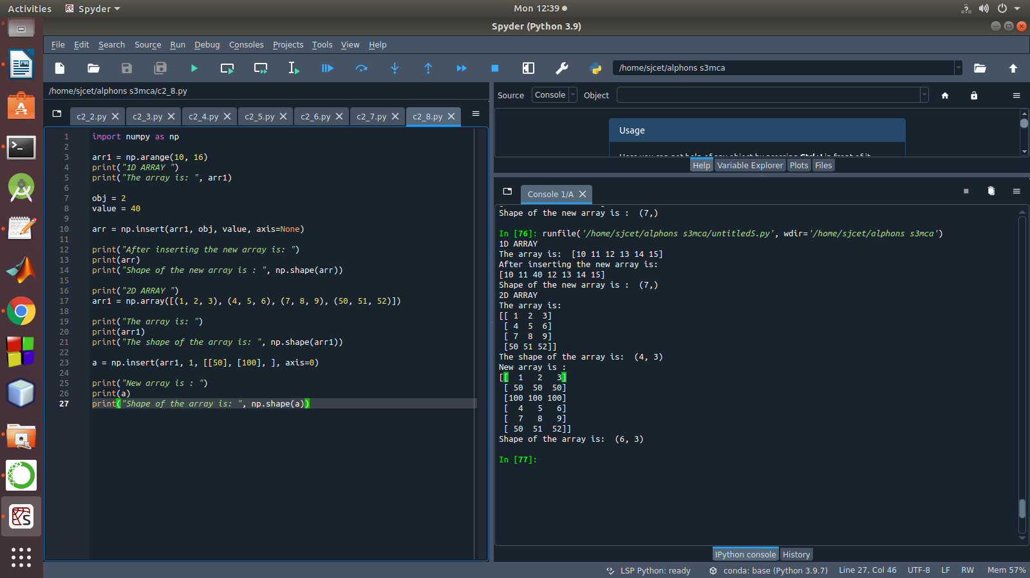

9. Demonstrate the use of diag() function in 1D and 2D array.
Program

import numpy as np
a= np.array([[3, 6,7,8]])
b=np.array([[3, 6,8,7], [4, 2,1,0],[3,1,3,3],[1,1,2,2]])
x=np.diag(a)
y=np.diag(b)
print(x)
print(y)

Output
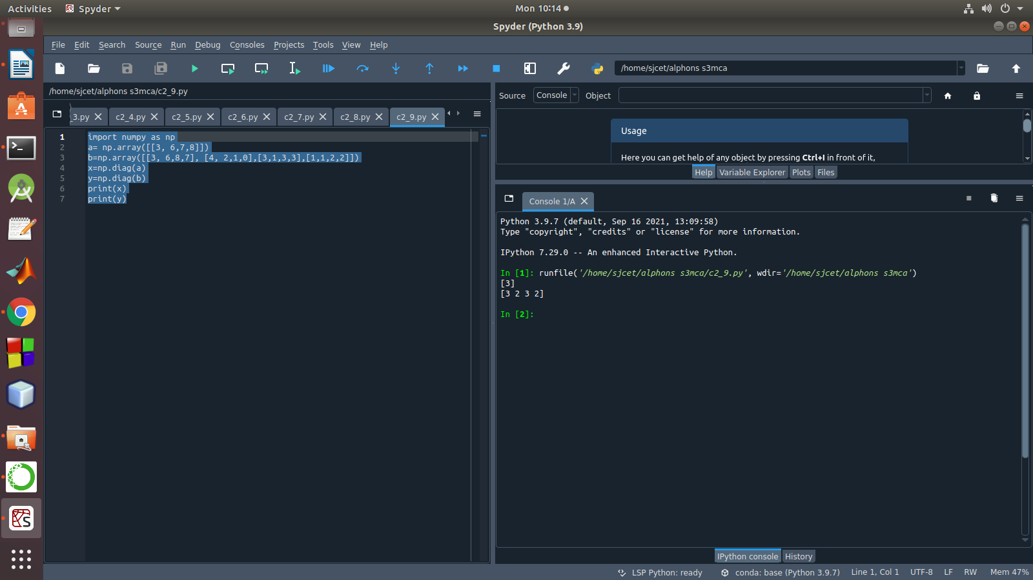

10. Demonstarte the use of append() function in 1D and 2D
array.
Program

import numpy as np
a = np.array([[1,2,3],[4,5,6]])
b=np.array([1,2,3])
print("First array:")
print (a)
print("Second array")
print(b)
print ("\n")
print ("Append elements to array:")
print (np.append(a, [7,8,9]))
print (np.append(b, [7,8,9]))

Output
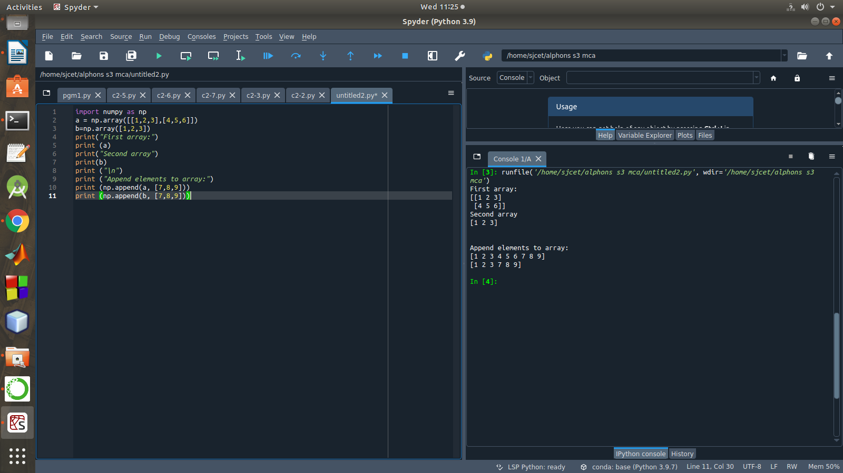

11. Demonstarte the use of sum() function in 1D and 2D array.
Program

import numpy as np
a=np.array([0.4,0.5])
b=np.sum(a)
print (b)

Output

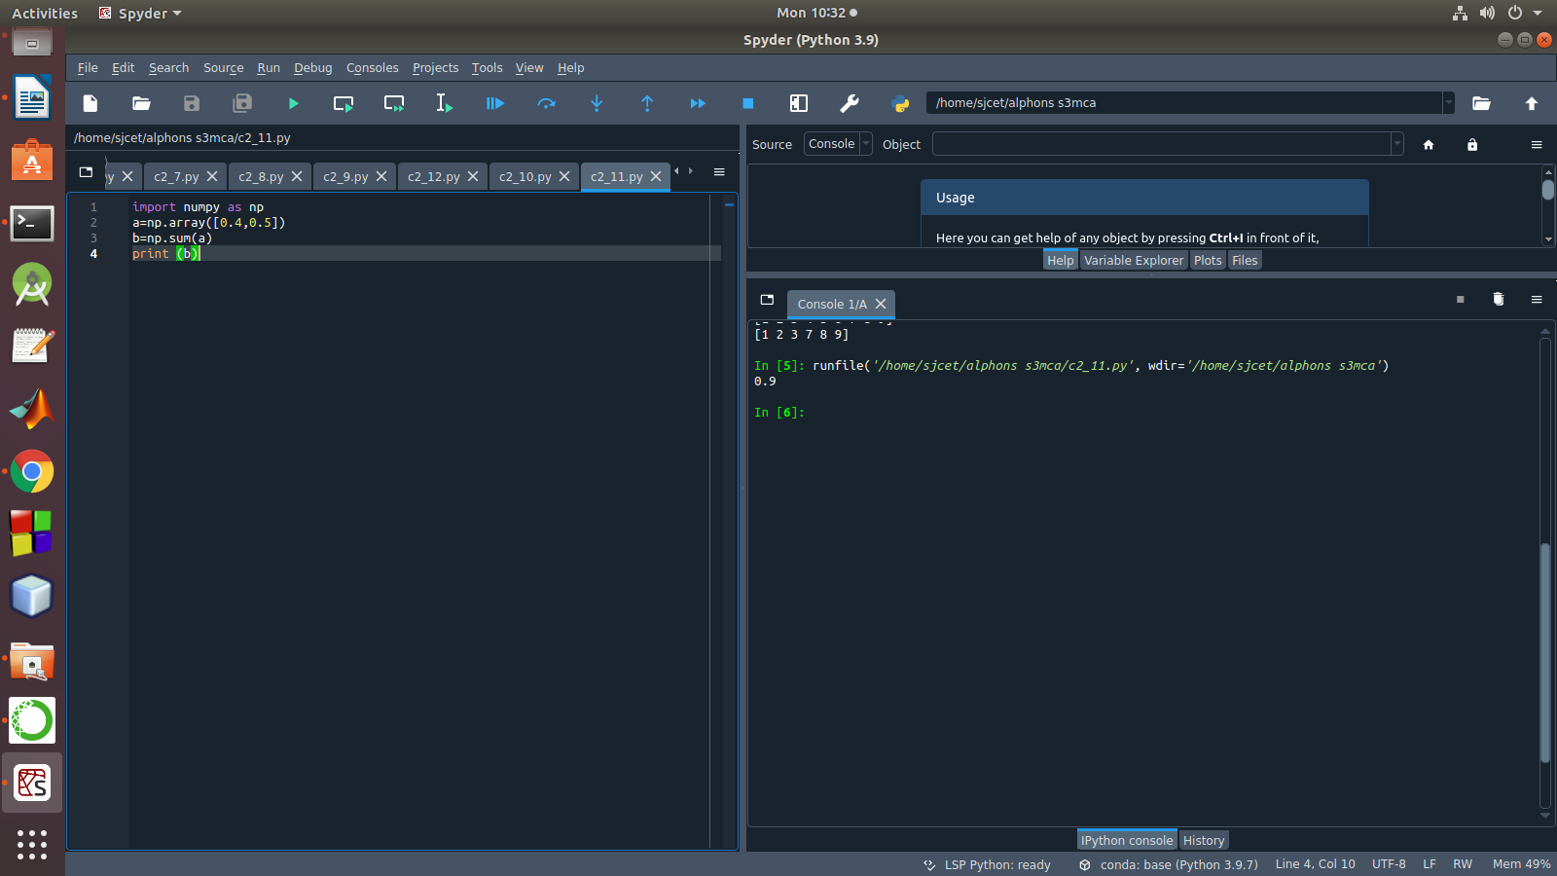

12.Create a 1 Dimensional array .Display the elements from indices 4 to 10 in descending order
Program

import numpy as np
a = np.array([1,2,8,9,3,4,5,6,7])
print(a)
array_copy = np.sort(a)[::-1]
print(array_copy[4:10])

Output
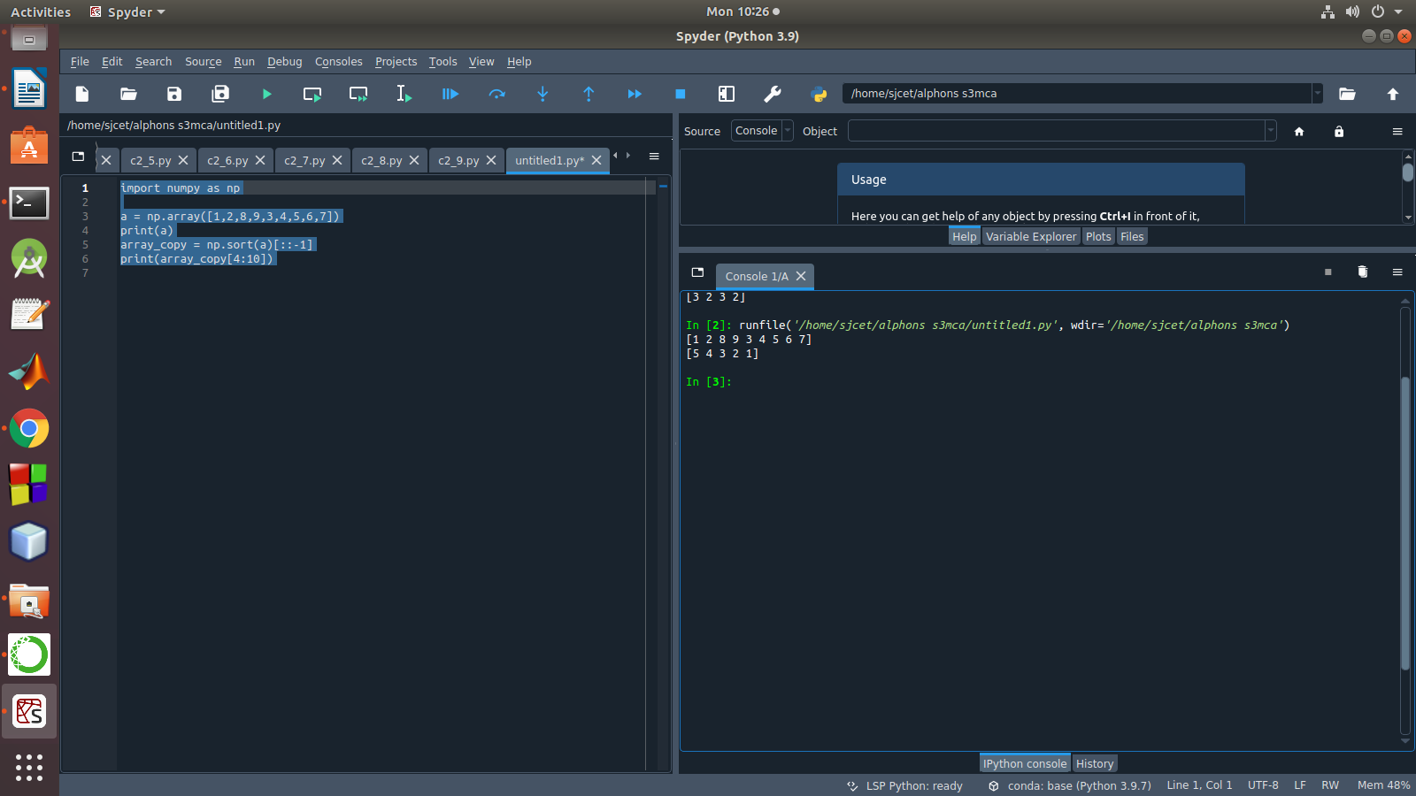

LAB CYCLE 2-PART 2

1.Matrix decomposition, also kn Create a square matrix with random integer values(use randint()) and use appropriate functions to find:
i) inverse
ii) rank of matrix
iii) Determinant
iv) transform matrix into 1D array
v) eigen values and vectors

Program

import numpy as np
import numpy as nf
from numpy.linalg import eig
mat = np.random.randint(10, size=(3, 3))
array = nf.random.randint(10, size=(3, 3))
print(mat)

M_inverse = np.linalg.inv(mat)
print("inverse of the array")
print(M_inverse)

rank = np.linalg.matrix_rank(mat)
print("Rank of the given Matrix ")
print(rank)

det= np.linalg.det(mat)
print("determinant of the given Matrix ")
print(det)

arr=mat.flatten()
print("transform matrix to array ")
print(arr)

w,v=eig(array)
print('E-value:', w)
print('E-vector', v)

Output

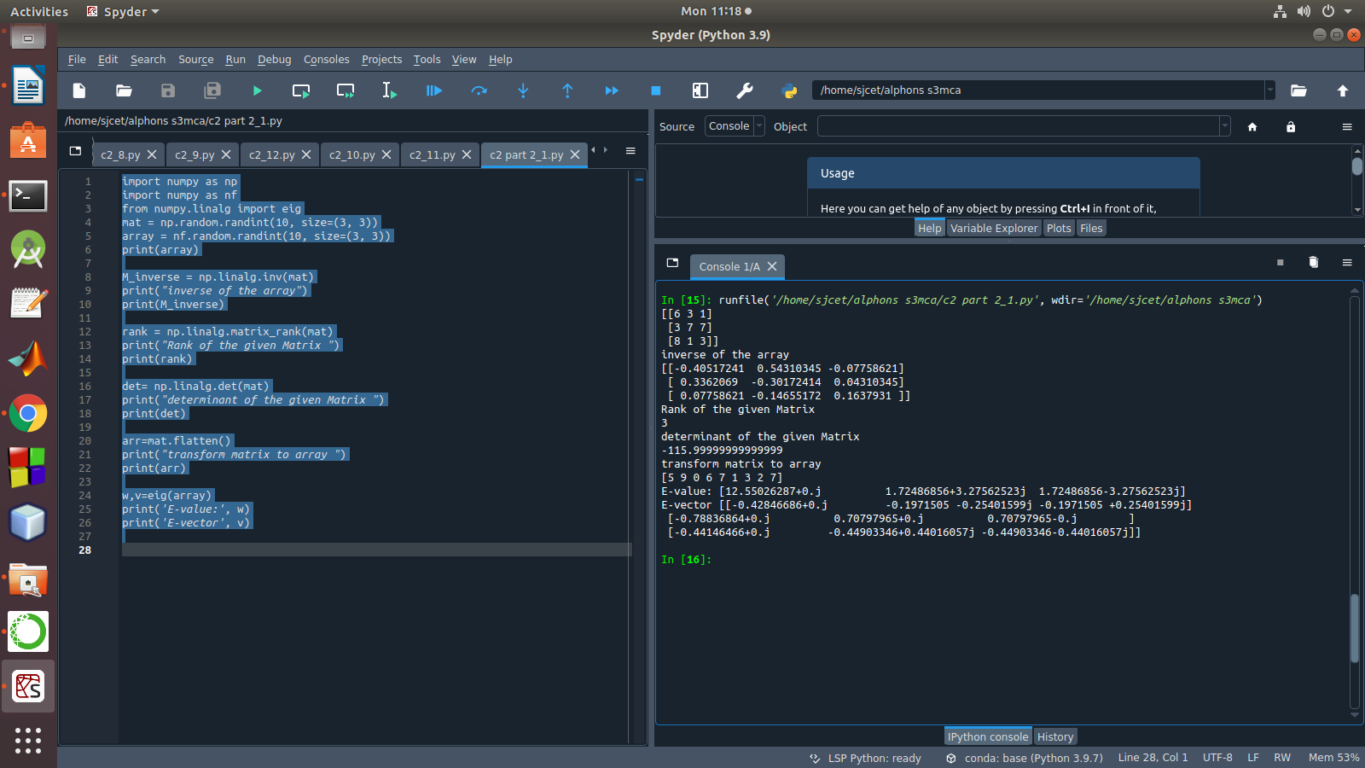

2. Create a matrix X with suitable rows and columns
i) Display the cube of each element of the matrix using different methods(use multiply(), *, power(),**)
ii) Display identity matrix of the given square matrix.
iii) Display each element of the matrix to different powers.
iv) Create a matrix Y with same dimension as X and perform the operation X²+2Y

Program

import numpy as np

matrix=np.random.randint(0,10,4).reshape(2,2)
print("Display the cube of each element of the matrix using different methods (use multiply(),*, power(),**)")
x=np.power(matrix,3)
print("power()",x)
y=np.multiply(matrix,(matrix*matrix))
print("multiply()")
print(y)
z=matrix*matrix*matrix
print("**")
print(z)
cube=matrix*3
print("*")
print(cube)
print("Display identity matrix of the given square matrix.")
identity=np.identity(2,dtype=int)
print(identity)
print("Display each element of the matrix to different powers.")
dpow=np.power(matrix,matrix)
print(dpow)
print("Create a matrix Y with same dimension as X and perform the operation X^2 +2Y")
a=np.add((np.power(x,2)),(np.multiply(y,2)))
print(a)

Output
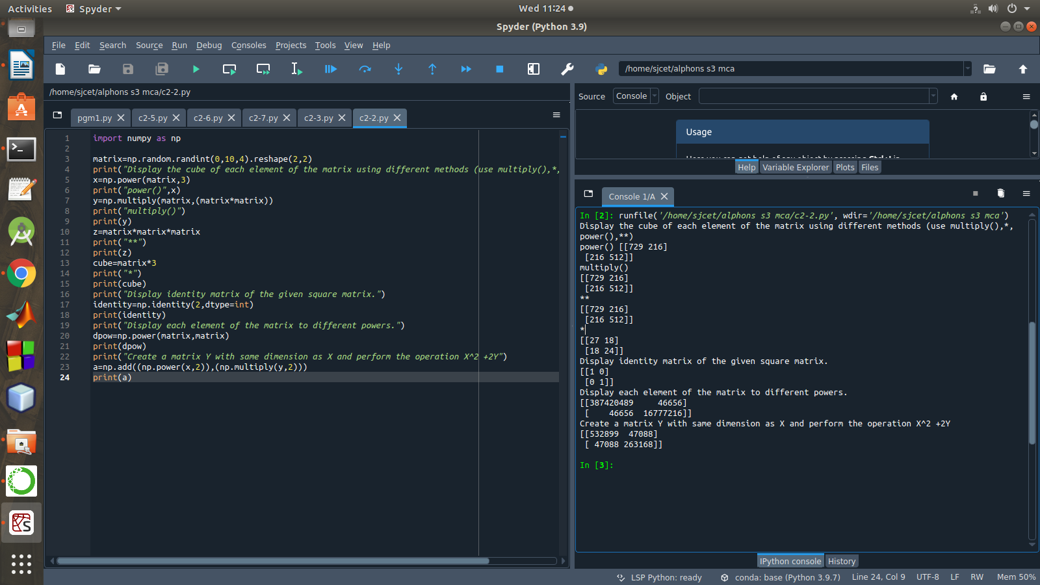

3. Multiply a matrix with a submatrix of another matrix and replace the same in larger matrix.
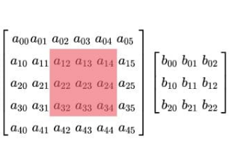

Program

import numpy as np
A = np.array([[6, 1, 1,6,3],
[4, -2, 5,1,3],
[2, 8, 7,7,8],
[6, 1, 1,6,3],
[2, 8, 7,7,8]])
B=np.array([[2, 1, -2],
[3, 0, 1],
[1, 1, -1]])
print("Mat A=\n",A)
print("Mat B=\n",B)
C=A[:3, :3]
res = np.dot(B,C)
print("Multiplication Result\n",res)
A[:3,:3]=res[:3,:3]
print("Resultant Matrix:\n",A)

Output

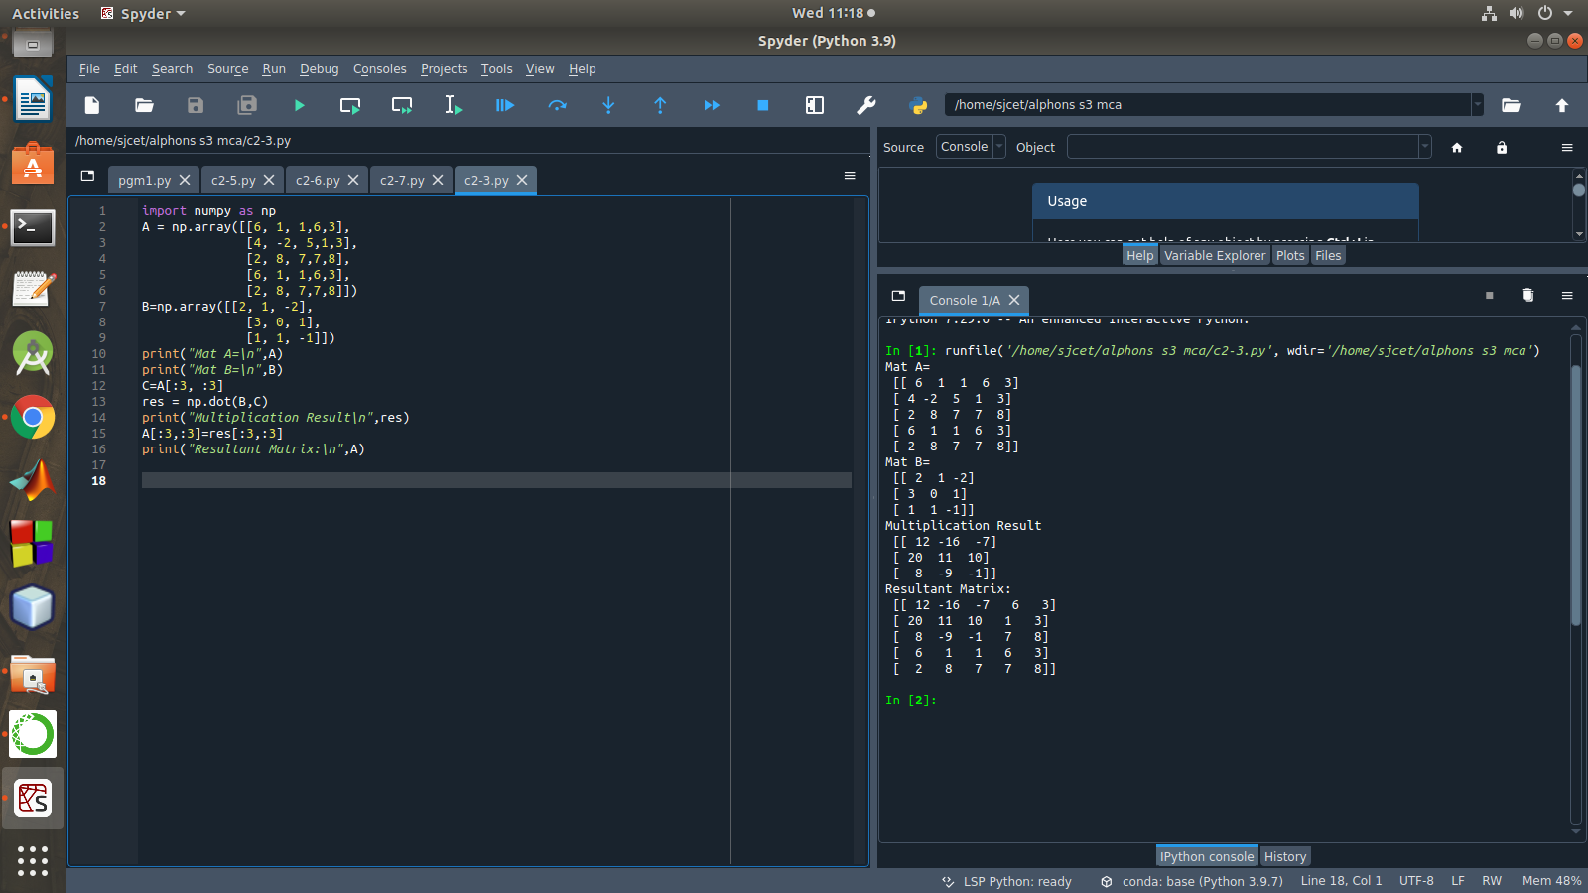

4.Given 3 Matrices A, B and C. Write a program to perform matrix multiplication of the 3 matrices.

Program
import numpy as np
m1 = np.random.randint(20, size=(2, 2))
print(m1)
m2 = np.random.randint(20, size=(2, 2))
print(m2)
m3 = np.random.randint(20, size=(2, 2))
print(m3)
print("multiplication of the 3 matrices")
m4 = np.dot(m1,m2,m3)
print(m4)

output
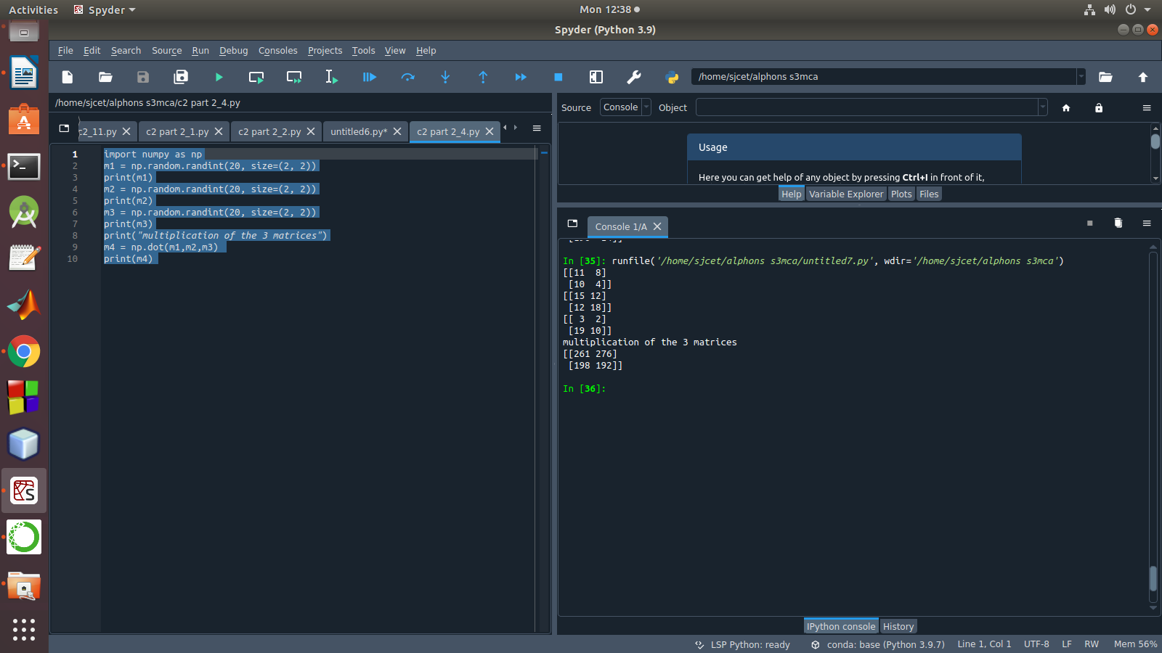

5. Write a program to check whether given matrix is symmetric or Skew Symmetric.

Program

import numpy as np
A = np.array([[6, 1, 1],
[4, -2, 5],
[2, 8, 7]])

inv=np.transpose(A)
print (inv)
neg=np.negative(A)
comparison = A == inv
comparison1 = inv== neg
equal_arrays = comparison.all()
skew=comparison1.all()
if equal_arrays :
print("Symmetric")
else:
print("not Symmetric")

if skew:
print("Skew Symmetric")
else:
print("Not Skew Symmetric")

output
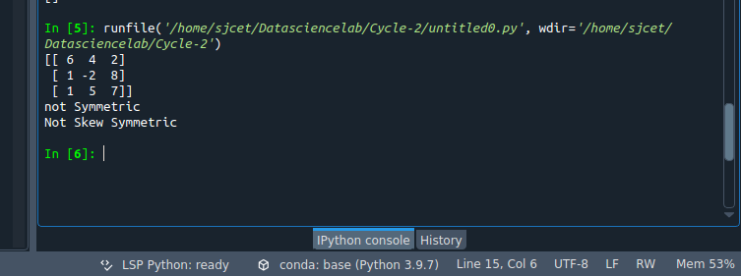

6. Write a program to find out the value of X using solve(), given A and b as above own as matrix factorization, involves describing a given matrix using its constituent elements.

Program
import numpy as np
A = np.array([[2, 1, -2],
[3, 0, 1],
[1, 1, -1]])
b=np.array([[3],
[5],
[-2]])
inv=np.linalg.inv(A)
x=np.linalg.solve(inv,b)
print(x)

Output
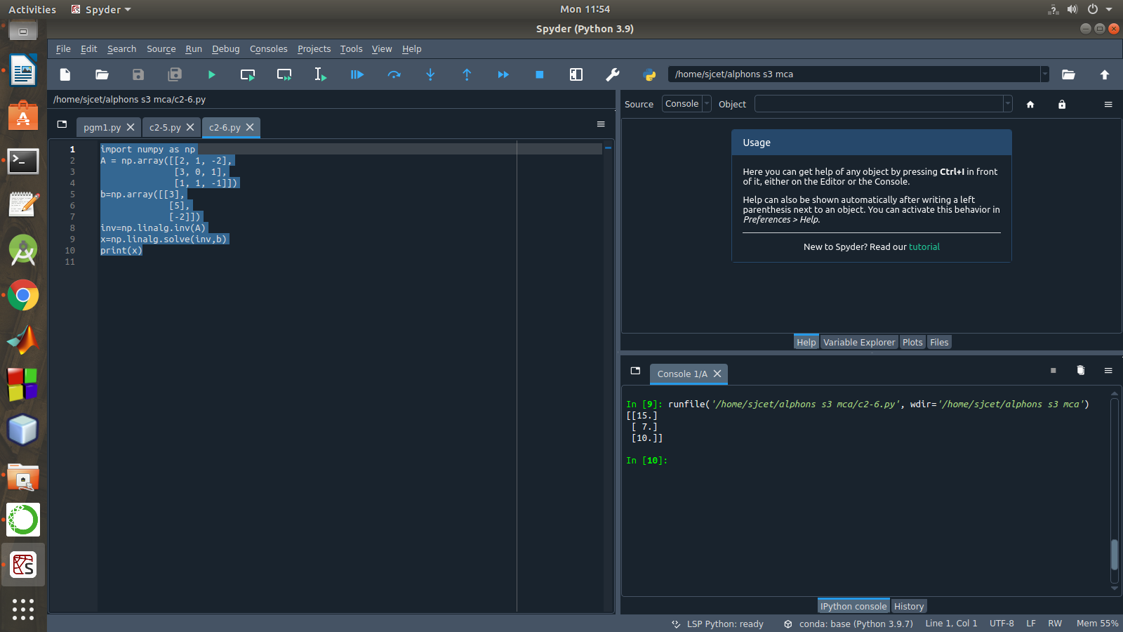

7 . Write a program to perform the SVD of a given matrix. Also reconstruct the given matrix from the 3 matrices obtained after performing SVD.

Program

from numpy import array
from scipy.linalg import svd
from numpy import diag
from numpy import dot
from numpy import zeros
# define a matrix
A = array([[1, 2], [3, 4], [5, 6]])
print(A)
# SVD
U, s, VT = svd(A)
print("first" ,U)
print("second",s)
print("3rd" ,VT)
Sigma = zeros((A.shape[0], A.shape[1]))
# populate Sigma with n x n diagonal matrix
Sigma[:A.shape[1], :A.shape[1]] = diag(s)
# reconstruct matrix
B = U.dot(Sigma.dot(VT))
print(B)

Output

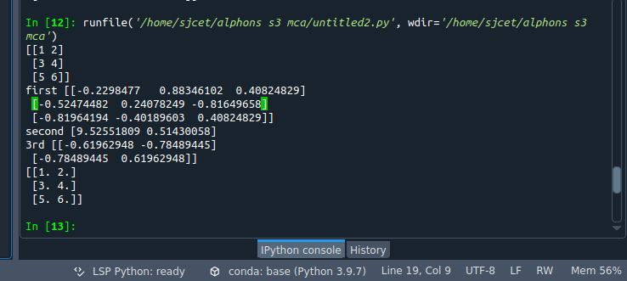

LAB CYCLE-3

LAB CYCLE 3-PART 1

1.Sarah bought a new car in 2001 for $24,000. The dollar value of her car changed each year as shown in the table below.
Value of Sarah's Car
Year Value
2001 $24,000
2002 $22,500
2003 $19,700
2004 $17,500
2005 $14,500
2006 $10,000
2007 $ 5,800
Represent the following information using a line graph with following style properties
- X- axis - Year
Y –axis - Car Value
- title –Value Depreciation (left Aligned)
- Line Style dashdot and Line-color should be red
- point using * symbol with green color and size 20

Subplot() provides multiple plots in one figure.

Program

import matplotlib.pyplot as plt
import numpy as np
xpoints = np.array([2001, 2002,2003,2004,2005,2006,2007])
ypoints = np.array([24000, 22500,19700,17500,14500,10000,5800])
plt.plot(xpoints, ypoints, '*g',ms = 20)
plt.plot(xpoints, ypoints, ':r')

leg = plt.legend(title="Value Depreciation ")
leg._legend_box.align = "left"

plt.show()

Output

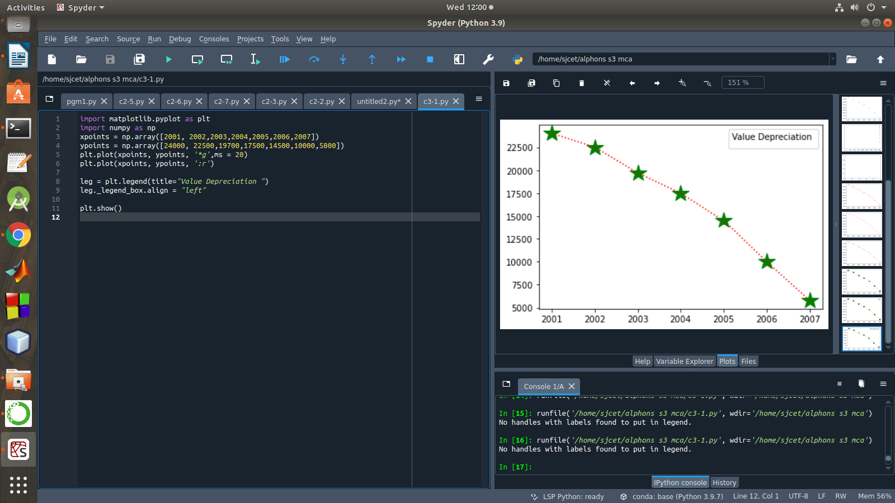

2.Following table gives the daily sales of the following items in a shop
Day | Mon | Tues | Wed | Thurs | Fri
Drinks | 300 | 450 | 150 | 400 | 650
Food | 400 | 500 | 350 | 300 | 500

Use subplot function to draw the line graphs with grids(color as blue and line style dotted) for the above information as 2 separate graphs in two rows
- Properties for the Graph 1:
- X label- Days of week
- Y label-Sale of Drinks
- Title-Sales Data1 (right aligned)
- Line –dotted with cyan color
- Points- hexagon shape with color magenta and outline black

- Properties for the Graph 2:
- X label- Days of Week
- Y label-Sale of Food
- Title-Sales Data2 ( center aligned)
- Line –dashed with yellow color
- Points- diamond shape with color green and outline red

Program
import matplotlib.pyplot as plt
import numpy as np

#plot 1:
x = np.array(['mon', 'tue', 'wed', 'thur','fri'])
y = np.array([300, 450, 150, 400,65])

plt.subplot(1, 2, 1)

plt.title("Sales Data1")
plt.xlabel("Days of week")
plt.ylabel("Sale of Drinks")
plt.plot(x,y,':c')
plt.plot(x,y,'Hm',mec = 'k')

plt.grid(color = 'blue', linestyle = 'dotted')
#plot 2:
c = np.array(['mon', 'tue', 'wed', 'thur','fri'])
v = np.array([400, 500, 350, 300,500])
plt.subplot(1, 2, 2)
plt.title("Sales Data2")
plt.xlabel("Days of Week")
plt.ylabel("Sale of Food")

plt.plot(c,v,'--y')
plt.plot(c,v,'Dg',mec = 'r')

plt.grid(color = 'blue', linestyle = 'dotted')
plt.show()

Output

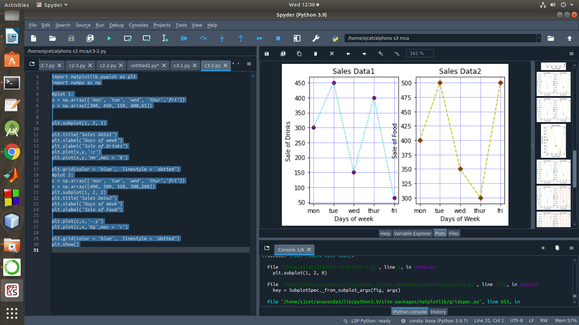
3. Create scatter plot for the below data:(use Scatter function)
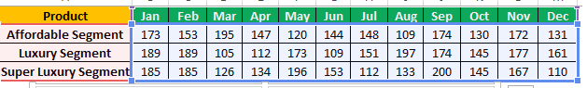

Create scatter plot for each Segment with following properties within one graph
- X Label- Months of Year with font size 18
- Y-Label- Sales of Segments
- Title –Sales Data
- Color for Affordable segment- pink
- Color for Luxury Segment- Yellow
- Color for Super luxury segment-blue

Program
import matplotlib.pyplot as plt
import numpy as np

plt.title("Sales Data")
plt.xlabel("Months of Year" ,size=18)
plt.ylabel("Sale of Food")
x = np.array(['Jan','Feb','Mar','Apr','May','Jun','Jul','Aug','Sep','Oct','Nov','Dec'])

y1 = np.array([173,153,195,147,120,144,148,109,174,130,172,131])
plt.scatter(x,y1, color = 'hotpink')

y2 = np.array([185,185,126,134,196,153,112,133,200,145,167,110])
plt.scatter(x, y2, color = 'yellow')

y3 = np.array([189,189,105,112,173,109,151,197,174,145,177,161])
plt.scatter(x, y3, color = 'blue')
plt.show()

Output
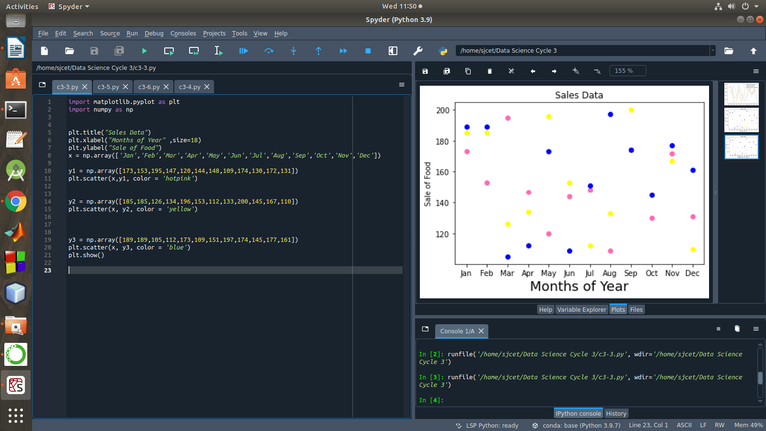

4.Display the above data using multiline plot( 3 different lines in same graph)
- Display the description of the graph in upper right corner(use legend())
- Use different colors and line styles for 3 different lines

Program

import matplotlib.pyplot as plt
import numpy as np

x = np.array(['Jan','Feb','Mar','Apr','May','Jun','Jul','Aug','Sep','Oct','Nov','Dec'])
y1 = np.array([173,153,195,147,120,144,148,109,174,130,172,131])
y2= np.array([189,189,105,112,173,109,151,197,174,145,177,161])
y3= np.array([185,185,126,134,196,153,112,133,200,145,167,110])

plt.plot(x,y1,label = "Affordable Segment",ls=':')
plt.plot(x,y2,label = "Luxuary Segment",ls="-")
plt.plot(x,y3,label = "Super Luxuary Segment",ls="-.")
plt.legend()
plt.show()

Output

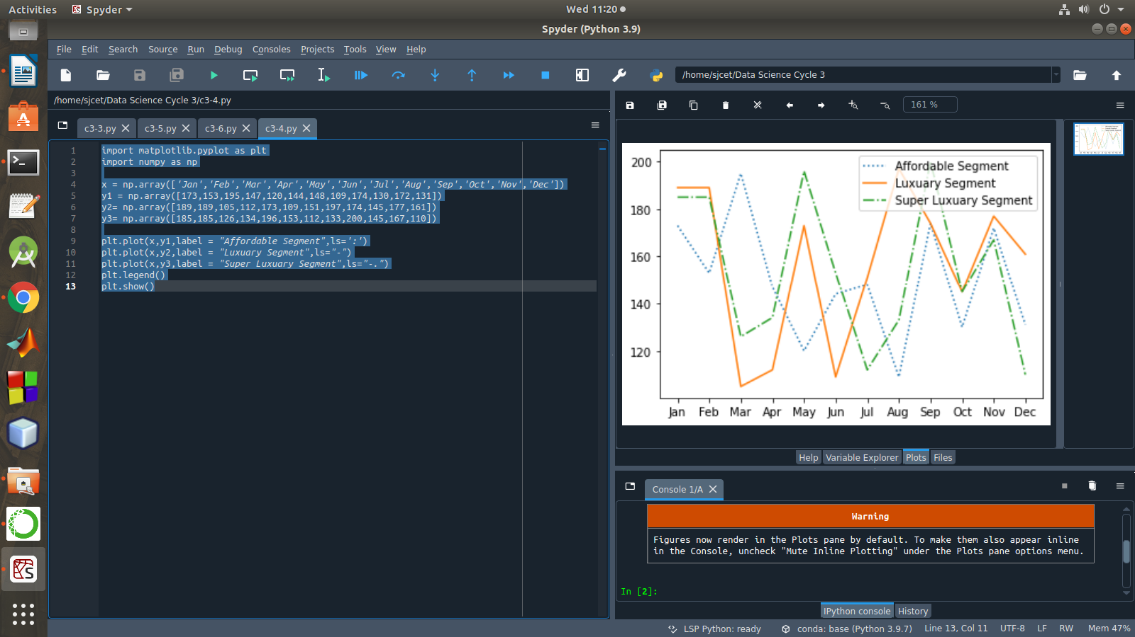
5.100 students were asked what their primary mode of transport for getting to school was. The results of this survey are recorded in the table below. Construct a bar graph representing this information.

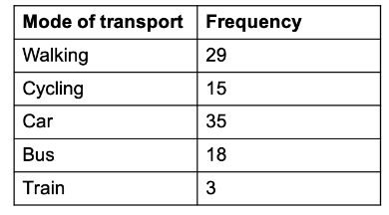
Create a bar graph with
- X axis -mode of Transport and Y axis ‘frequency’
- Provide appropriate labels and title
- Width .1, color green

Program
import matplotlib.pyplot as plt
import numpy as np

plt.title("Students transportation")
plt.xlabel("Mode of Transport")
plt.ylabel("Frequency")

x = np.array(["walking","cycling","car","bus","train"])
y = np.array([29,15,35,18,3])

plt.bar(x, y, color = "#4CAF50",width = 0.1)
plt.show()

Output
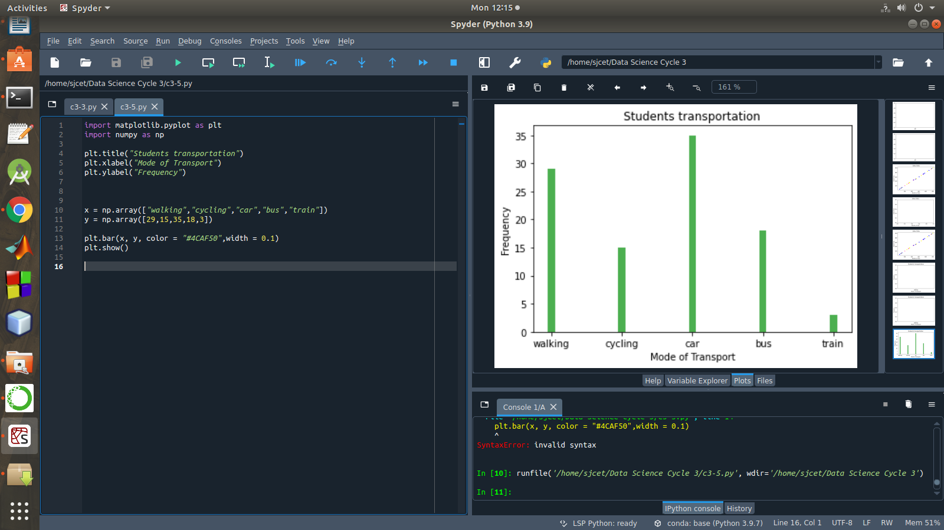

6.We are provided with the height of 30 cherry trees.
The height of the trees (in inches): 61, 63, 64, 66, 68, 69, 71, 71.5, 72, 72.5, 73, 73.5, 74, 74.5, 76, 76.2, 76.5, 77, 77.5, 78, 78.5, 79, 79.2, 80, 81, 82, 83, 84, 85, 87.Create a histogram with a bin size of 5

Program

import matplotlib.pyplot as plt

height = [61,63,64,66,68,69,
71,71.5,72,72.5,73,73.5,74,74.5,76,76.2,76.5,77,77.5,78,78.5,79,79.2,80,81,82,83,84,85,87
]
plt.hist(height, edgecolor="red", bins=5)
plt.show()

Output
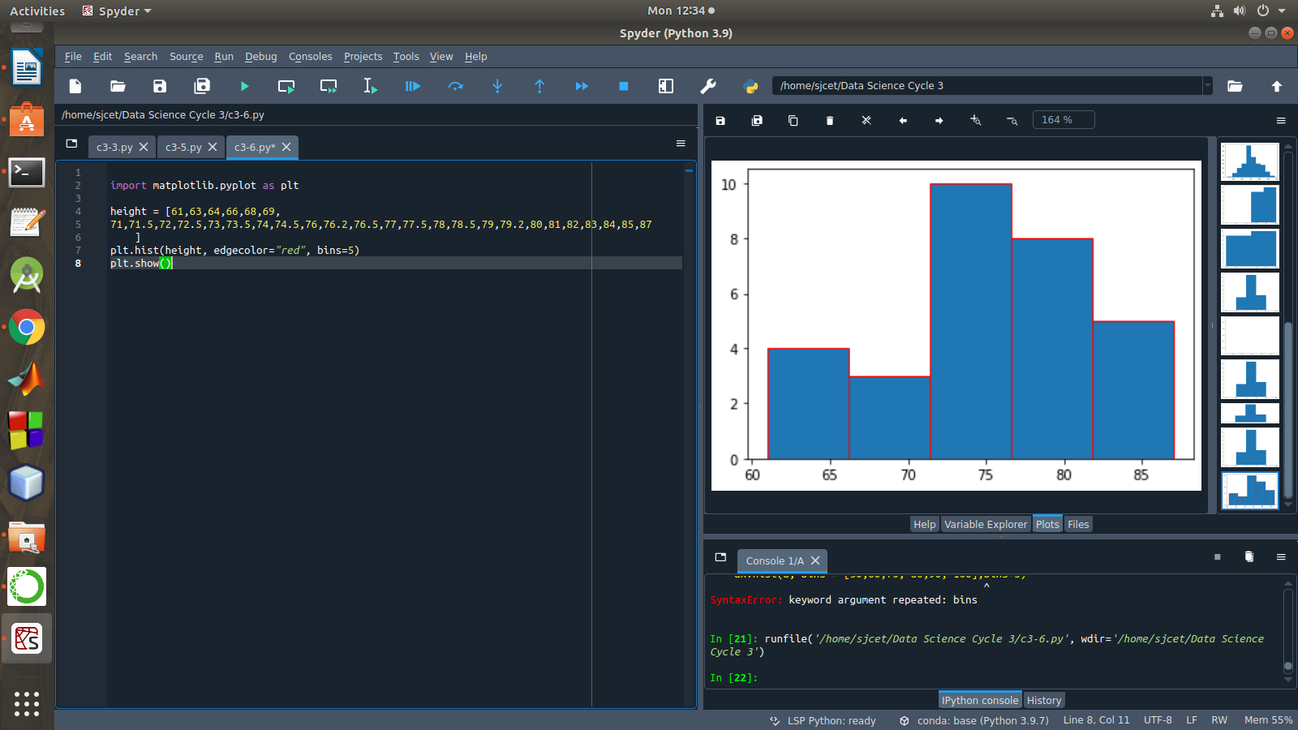

LAB CYCLE 3 PART-2

DATA HANDLING USING ‘Pandas’ and DATA VISUALIZATION USING ‘Seaborn’
Using the pandas function read_csv(), read the given ‘iris’ data set.

- Use appropriate functions in pandas to display
- Shape of the data set
- First 5 and last five rows of data set(head and tail)
- Size of dataset
- No:of samples available for each variety
- Description of the data set( use describe

PROGRAM

import numpy as np
import matplotlib.pyplot as plt
import seaborn as sns
import pandas as pd
col=['sepal_length','sepal_width','petal_length','petal_width','type']
iris=pd.read_csv("iris.csv",names=col)

print("First five rows")
print(iris.head())
print("*********")
print("columns",iris.columns)
print("*********")
print("shape:",iris.shape)
print("*********")
print("Size:",iris.size)
print("*********")
print("no of samples available for each type")
print(iris["type"].value_counts())
print("*********")
print(iris.describe())

OUTPUT
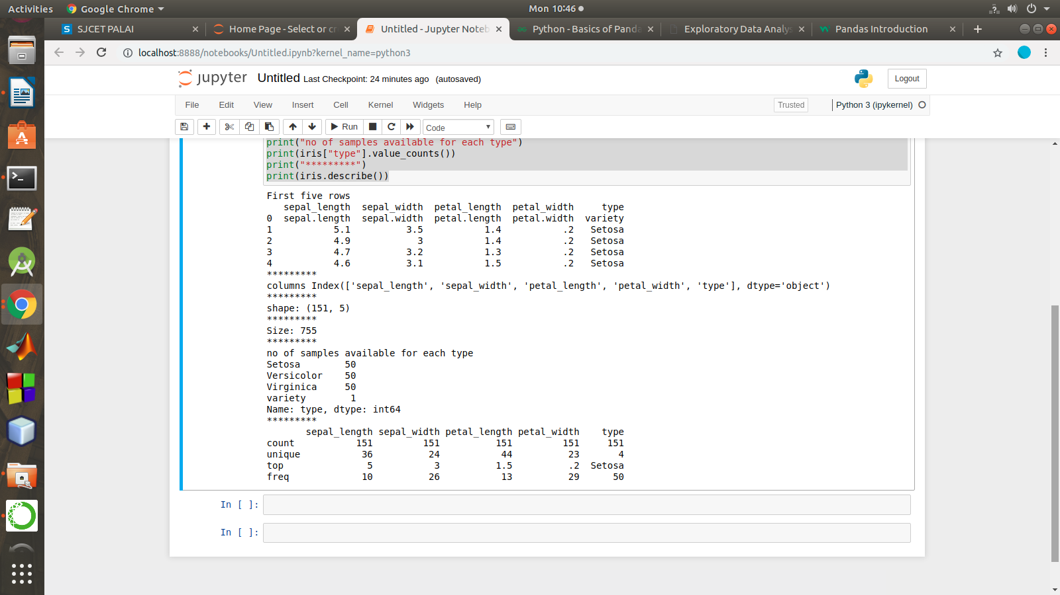

2. Use pairplot() function to display pairwise relationships between attributes. Try different kind of plots {‘scatter’, ‘kde’, ‘hist’, ‘reg’} and different kind of markers

PROGRAM

import numpy as np
import pandas as pd
import seaborn as sns

import matplotlib.pyplot as plt
%matplotlib inline

iris = sns.load_dataset('iris')
my_data_frame = pd.DataFrame(iris)

g = sns.pairplot(my_data_frame)
g = sns.pairplot(iris, kind="reg", hue="species")
g = sns.pairplot(iris, kind="hist", hue="species")
g = sns.pairplot(iris, kind="kde", hue="species")
g = sns.pairplot(iris, kind="scatter", hue="species")

OUTPUT

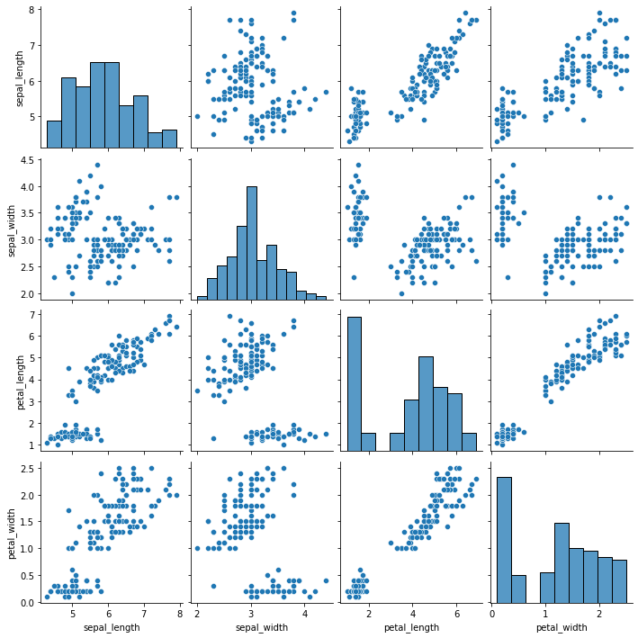

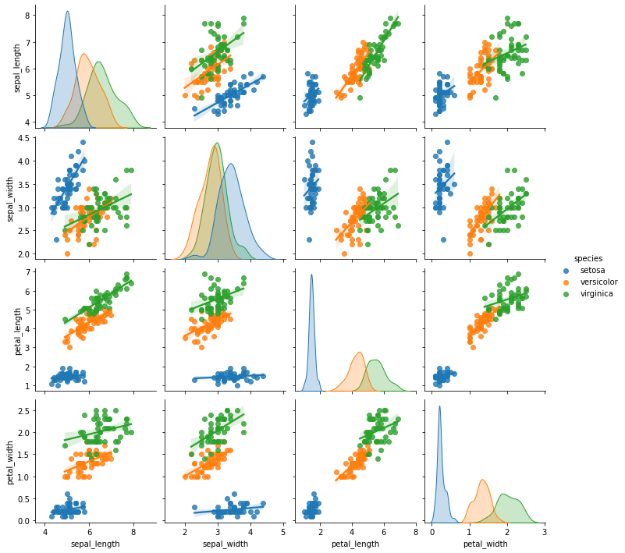
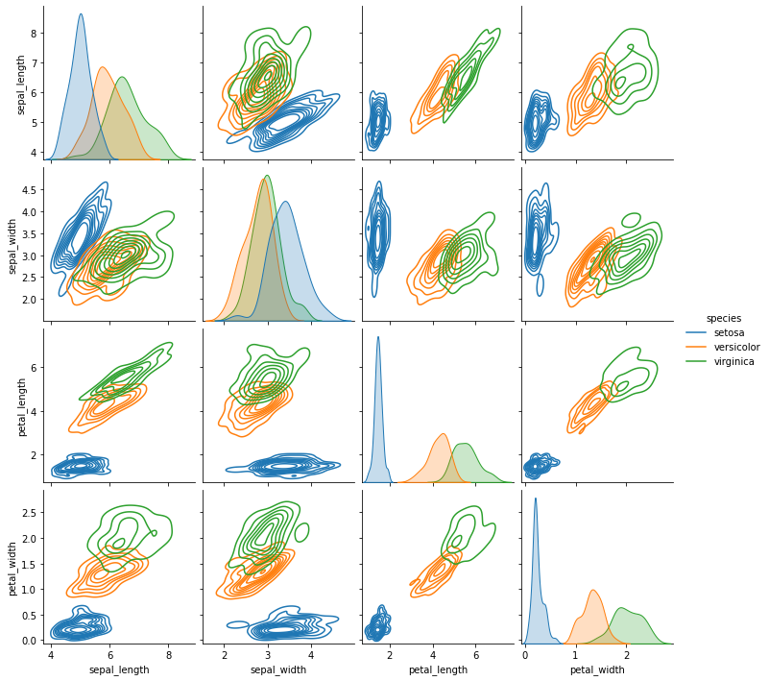

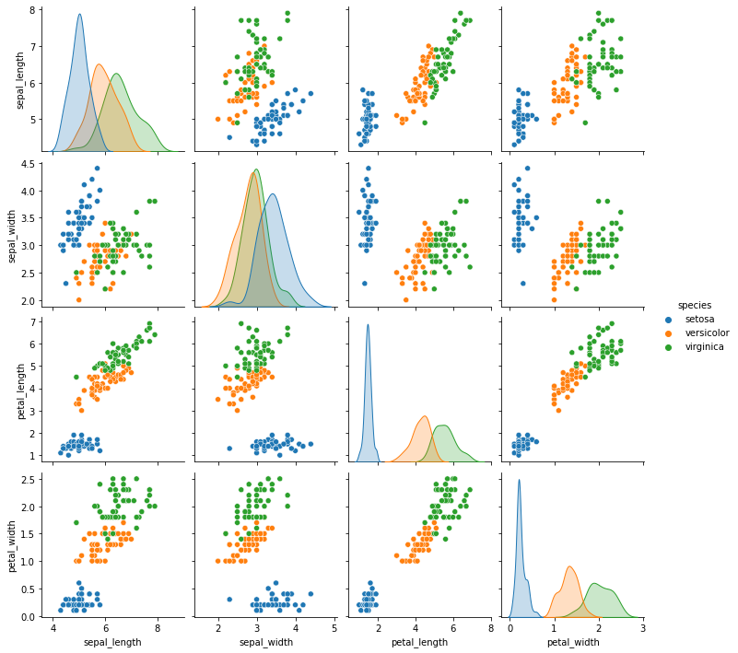

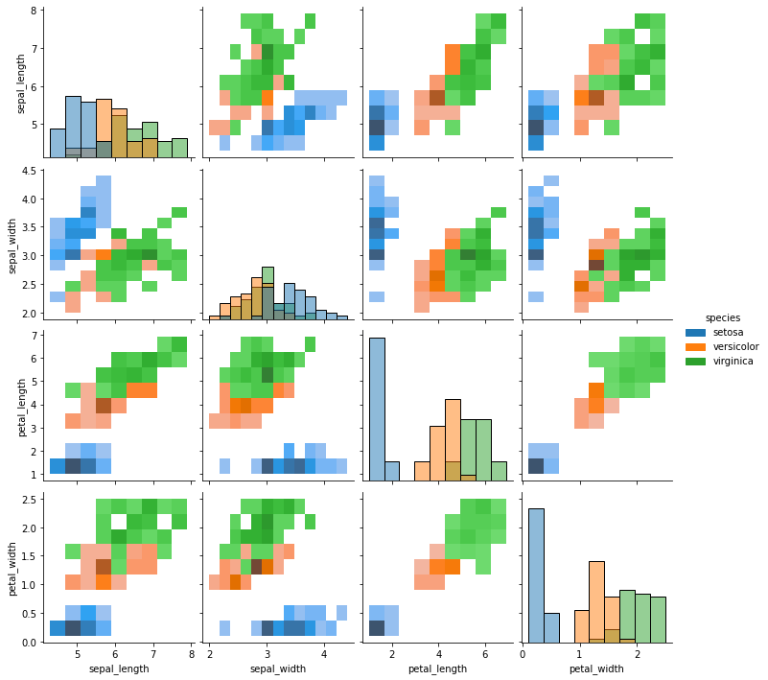

3. using the iris data set,get familiarize with functions:
1)displot()
Program
import seaborn as sns

import pandas
import matplotlib.pyplot as plt
sns.get_dataset_names()
df = sns.load_dataset('iris')
df.head()
sns.displot(x = 'sepal_length',kde=True,bins = 5 , data =df)

output

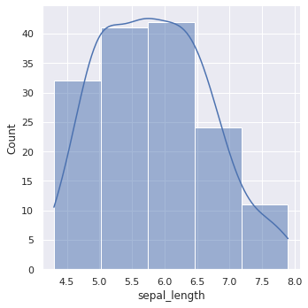

2) histplot()

program
import seaborn as sns
import pandas
import matplotlib.pyplot as plt
sns.get_dataset_names()
df = sns.load_dataset('iris')
df.head()
sns.histplot(x = 'sepal_length',kde=True,bins = 6 , data =df)
Output
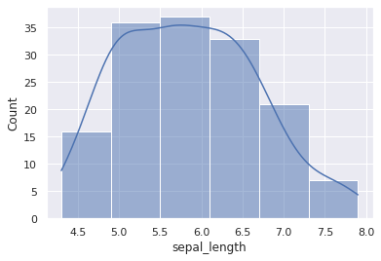

3) relplot()
program
import seaborn as sns
sns.set(style ="ticks")
dataset = sns.load_dataset('iris')
col=['sepal_length','sepal_width','petal_length','petal_width','type']
sns.relplot(x ="sepal_length", y ="petal_width", data = dataset)

Output

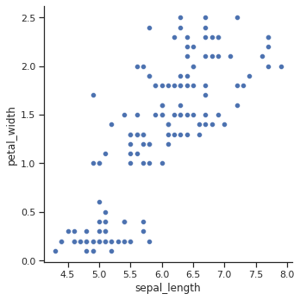

LAB CYCLE-4

LAB CYCLE 4 PART-1

1)Using the iris data set implement the KNN algorithm. Take different values for Test and training data set .Also use different values for k. Also find the accuracy level.Using the iris data set implement the KNN algorithm. Take different values for Test and training data set .Also use different values for k. Also find the accuracy level.

PROGRAM

import numpy as np
import matplotlib.pyplot as plt
import pandas as pd
dataset = pd.read_csv("iris.csv")
X = dataset.iloc[:, :-1].values
y = dataset.iloc[:, 4].values
from sklearn.model_selection import train_test_split
X_train, X_test, y_train, y_test = train_test_split(X, y, test_size=0.20)
from sklearn.neighbors import KNeighborsClassifier
classifier = KNeighborsClassifier(n_neighbors=5)
classifier.fit(X_train, y_train)
y_pred = classifier.predict(X_test)
from sklearn.metrics import classification_report, confusion_matrix
print(classification_report(y_test, y_pred))

from sklearn.metrics import accuracy_score
print ("Accuracy : ", accuracy_score(y_test, y_pred))
df = pd.DataFrame({'Real Values':y_test, 'Predicted Values':y_pred})

OUTPUT
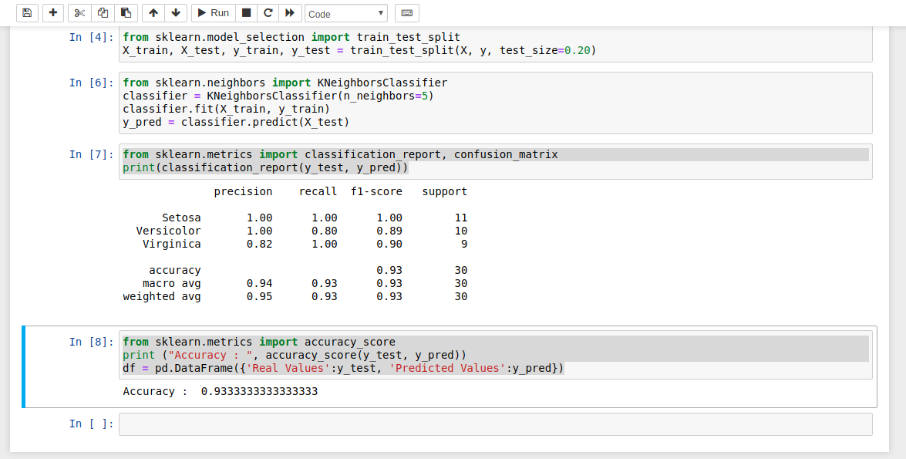

2. Download another data set suitable for the KNN and implement the KNN algorithm. Take different
values for Test and training data set .Also use different values for k.

PROGRAM

import numpy as np
import matplotlib.pyplot as plt
import pandas as pd
dataset = pd.read_csv("cancer.csv")
dataset.head()
dataset.info()
X = dataset.iloc[:, 2:35].values
print(X)
y = dataset.iloc[:, 1].values
print(y)
from sklearn.model_selection import train_test_split
X_train, X_test, y_train, y_test = train_test_split(X, y, test_size=0.20)
from sklearn.neighbors import KNeighborsClassifier
classifier = KNeighborsClassifier(n_neighbors=5)
classifier.fit(X_train, y_train)
y_pred = classifier.predict(X_test)
from sklearn.metrics import classification_report, confusion_matrix
print(classification_report(y_test, y_pred))
from sklearn.metrics import accuracy_score
print ("Accuracy : ", accuracy_score(y_test, y_pred))
df = pd.DataFrame({'Real Values':y_test, 'Predicted Values':y_pred})
OUTPUT
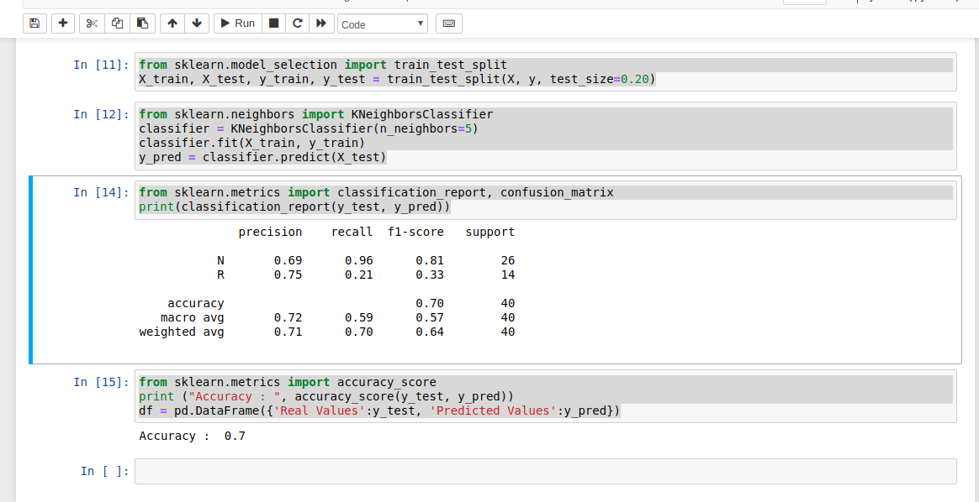

3. Using iris data set, implement naive bayes classification for different naive Bayes classification
algorithms.( (i) gaussian (ii) bernoulli etc)

• Find out the accuracy level w.r.t to each algorithm
• Display the no:of mislabeled classification from test data set
• List out the class labels of the mismatching records

import numpy as np
import matplotlib.pyplot as plt
import pandas as pd

dataset = pd.read_csv('iris.csv')
X = dataset.iloc[:,:4].values
y = dataset['variety'].values
dataset.head(5)
from sklearn.model_selection import train_test_split
X_train, X_test, y_train, y_test = train_test_split(X, y, test_size = 0.2)

from sklearn.naive_bayes import GaussianNB
classifier = GaussianNB()
classifier.fit(X_train, y_train)
y_pred = classifier.predict(X_test)
y_pred
from sklearn.metrics import confusion_matrix
cm = confusion_matrix(y_test, y_pred)

from sklearn.metrics import accuracy_score
print ("Accuracy : ", accuracy_score(y_test, y_pred))
cm
df = pd.DataFrame({'Real Values':y_test, 'Predicted Values':y_pred})
df
OUTPUT

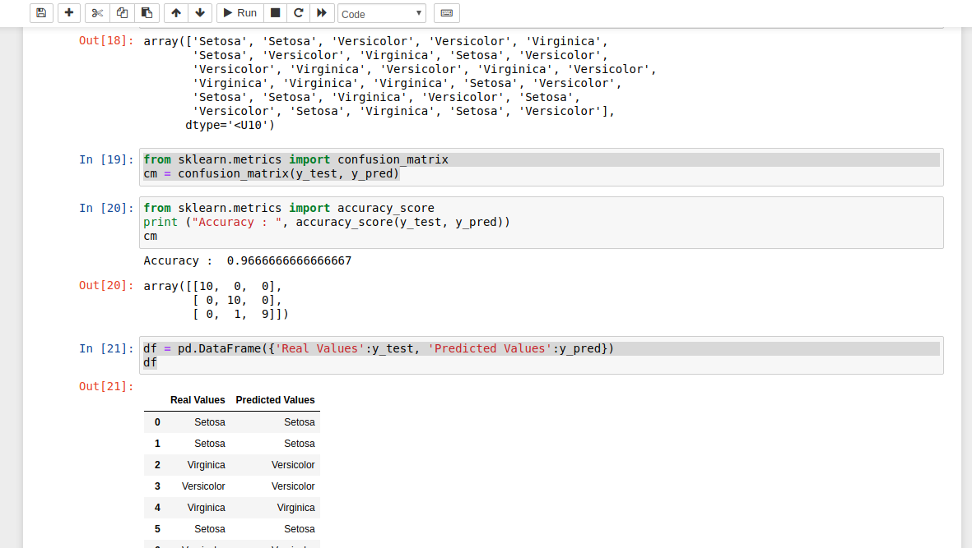

4. Use car details CSV file and implement decision tree algorithm
• Find out the accuracy level.
• Display the no:of mislabeled classification from test data set
• List out the class labels of the mismatching records

import os
import numpy as np
import pandas as pd
import numpy as np, pandas as pd
import matplotlib.pyplot as plt
from sklearn import tree, metrics, model_selection

data = pd.read_csv('car.csv',names=['buying','maint','doors','persons','lug_boot','safety','class'])
data.head()
data.info()

data['class'],class_names = pd.factorize(data['class'])

print(class_names)
print(data['class'].unique())

data['buying'],_ = pd.factorize(data['buying'])
data['maint'],_ = pd.factorize(data['maint'])
data['doors'],_ = pd.factorize(data['doors'])
data['persons'],_ = pd.factorize(data['persons'])
data['lug_boot'],_ = pd.factorize(data['lug_boot'])
data['safety'],_ = pd.factorize(data['safety'])
data.head()
data.info()
X = data.iloc[:,:-1]
y = data.iloc[:,-1]

# split data randomly into 70% training and 30% test
X_train, X_test, y_train, y_test = model_selection.train_test_split(X, y, test_size=0.3, random_state=0)

# train the decision tree
dtree = tree.DecisionTreeClassifier(criterion='entropy', max_depth=3, random_state=0)
dtree.fit(X_train, y_train)
# use the model to make predictions with the test data
y_pred = dtree.predict(X_test)
# how did our model perform?
accuracy = metrics.accuracy_score(y_test, y_pred)
print('Accuracy: {:.2f}'.format(accuracy))
count_misclassified = (y_test != y_pred).sum()
print('Misclassified samples: {}'.format(count_misclassified))
OUTPUT

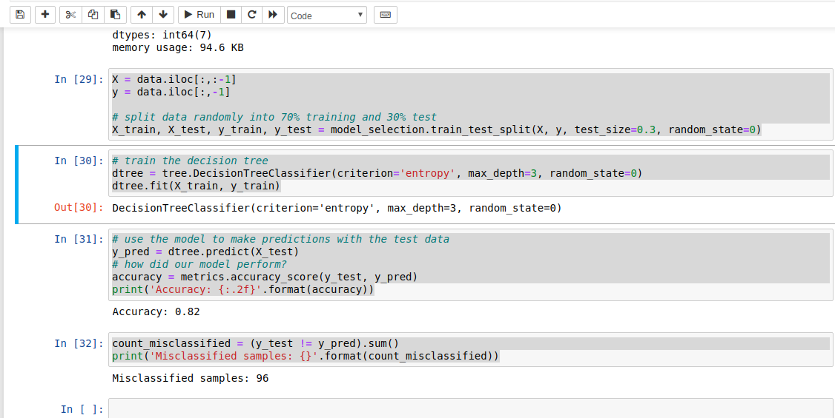

LAB CYCLE 4 PART -2

1).Implement Simple and multiple linear regression for the data sets ‘student_score.csv’ and ‘company_data .csv’ respectively

import numpy as np
import pandas as pd
import matplotlib.pyplot as plt

#data set contains details of no.of hours spend by students for studt and their marks
student = pd.read_csv('student_scores.csv')
student.head()
student.describe()

student.info()
import matplotlib.pyplot as plt

Xax=student.iloc[:,0]
Yax=student.iloc[:,1]
plt.scatter(Xax,Yax)
plt.xlabel("No.of hours")
plt.ylabel("Score")
plt.title("Student scores")
plt.show()
#Perform the simple linear regression model
#Equation: Y=w0+w1.x
#Here Y(marks)=w0+w1.x
#Create x as hours and Y as marks

X = student.iloc[:, :-1]
y = student.iloc[:, 1]
print(X)
print(y)

from sklearn.model_selection import train_test_split
X_train, X_test, y_train, y_test = train_test_split(X, y, test_size=0.2)
print(X_train)
from sklearn.linear_model import LinearRegression
regressor = LinearRegression()
regressor.fit(X_train, y_train)
print(regressor.intercept_)
print(regressor.coef_)
y_pred = regressor.predict(X_test)
for(i,j) in zip(y_test,y_pred):
if i!=j:
print("Actual value :",i,"Predicted value :",j)
print("Number of mislabeled points from test data set :", (y_test != y_pred).sum())
from sklearn import metrics
print("Mean Absolute error :", metrics.mean_absolute_error(y_test,y_pred))
print("Mean Squared error :", metrics.mean_squared_error(y_test,y_pred))
print("Root Mean Squared error :", np.sqrt(metrics.mean_squared_error(y_test,y_pred)))
import matplotlib.pyplot as plt
c=X_test['Hours'].count()
xax=np.arange(c)
print(xax)
X_axis = np.arange(len(xax))
plt.bar(X_axis-0.2, y_test, 0.6, label='Actual')
plt.bar(X_axis+0.2, y_pred, 0.6, label='Predicted')

plt.xlabel("Test Records")
plt.ylabel("Marks")
plt.title("Student Score prediction")
plt.legend()
plt.show()
OUTPUT
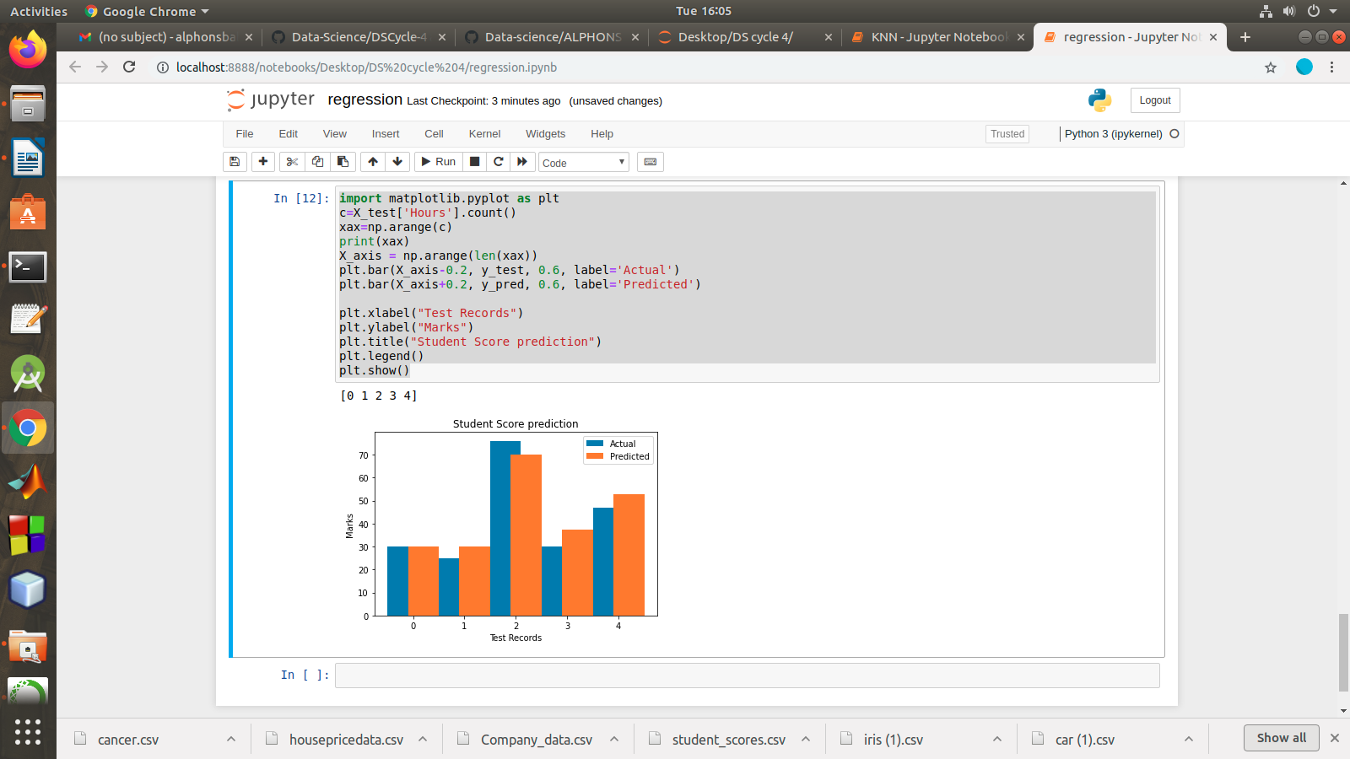

2.)multiple linear regression for the data sets ‘student_score.csv’ and ‘company_data .csv’ respectively

import pandas as pd
import numpy as np
import matplotlib.pyplot as plt
advertising = pd.read_csv('Company_data.csv')
advertising.head()
advertising.describe()

advertising.info()

import matplotlib.pyplot as plt
import seaborn as sns
sns.pairplot(advertising, x_vars=['TV', 'Radio', 'Newspaper'],
y_vars='Sales', height=5, aspect=1, kind='scatter')
plt.show()

#perform the multiple linear regression model
#Equation : Y=w0+w1.x1 + w2.x2 + w3.x3
#Here Y(sales)=w0+w1.x1(TV)+w2.x2(Radio)+w3.x3(Newspaper)
#create x and Y as sales

X = advertising.iloc[:, :-1]
print(X)
y = advertising.iloc[:, -1]
print(y)
from sklearn.model_selection import train_test_split
X_train, X_test, y_train, y_test = train_test_split(X, y, test_size=0.3)
print(X_train)
from sklearn.linear_model import LinearRegression
regressor = LinearRegression()
regressor.fit(X_train, y_train)
print(regressor.intercept_)
print(regressor.coef_)
y_pred = regressor.predict(X_test)
for(i,j) in zip(y_test,y_pred):
if i!=j:
print("Actual value :",i,"Predicted value :",j)
print("Number of mislabeled points from test data set :", (y_test != y_pred).sum())
from sklearn import metrics
print("Mean Absolute error :", metrics.mean_absolute_error(y_test,y_pred))
print("Mean Squared error :", metrics.mean_squared_error(y_test,y_pred))
print("Root Mean Squared error :", np.sqrt(metrics.mean_squared_error(y_test,y_pred)))
import matplotlib.pyplot as plt
c=X_test['TV'].count()
xax=np.arange(c)
print(xax)
X_axis = np.arange(len(xax))
plt.bar(X_axis-0.2, y_test, 0.6, label='Actual')
plt.bar(X_axis+0.2, y_pred, 0.6, label='Predicted')

plt.xlabel("Sales")
plt.ylabel("Actual/Predicted")
plt.title("Sales prediction")
plt.legend()
plt.show()
OUTPUT

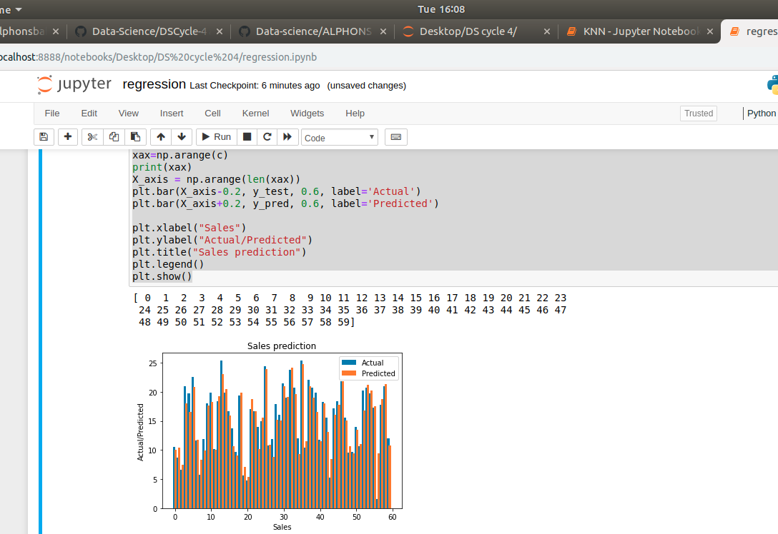

LAB CYCLE 4 PART -3

Experiment:
- Create a neural network for the given ‘houseprice.csv’ to predict the whether price of the house is above or below median value or not
Keras allows you to train your model using stochastic, batch, or minibatch gradient descent.
- Batch Gradient Descent. Batch size is set to the total number of examples in the training dataset.
- Stochastic Gradient Descent. Batch size is set to one.
- Minibatch Gradient Descent. Batch size is set to more than one and less than the total number of examples in the training dataset.

Cost Functions
The three most common loss(cost) functions are:
- ‘binary_crossentropy‘ for binary classification.
- ‘sparse_categorical_crossentropy‘ for multi-class classification.
- ‘mse‘ (mean squared error) for regression.

Different Optimizers
- SGD.
- RMSprop.
- Adam.
- Adadelta.
- Adagrad.
- Adamax.
- Nadam.
- Ftrl.

Fit the Model
Fitting the model requires that you first select the training configuration, such as the number of epochs (loops through the training dataset) and the batch size (number of samples in an epoch used to estimate model error).

A subset of the training dataset is used to estimate the error and update the weights.
The number of examples from the training dataset used in the estimate of the error gradient is called the batch size

A batch size of 32 means that 32 samples from the training dataset will be used to estimate the error gradient before the model weights are updated. One training epoch means that the learning algorithm has made one pass through the training dataset, where examples were separated into randomly selected “batch size” groups.

Activation Functions
ReLU function is suitable for using in hidden layers
Sigmoid function is commonly used in output layer for binary classification
Softmax activation function should be used in the output layer in case of multiclass classification.

import tensorflow as tf
import keras
import pandas
import sklearn
import matplotlib
import pandas as pd

df = pd.read_csv('housepricedata.csv')
df
dataset = df.values
dataset
X = dataset[:,0:10]
Y = dataset[:,10]

from sklearn import preprocessing
min_max_scaler = preprocessing.MinMaxScaler()
X_scale = min_max_scaler.fit_transform(X)
X_scale
from sklearn.model_selection import train_test_split
X_train, X_val_and_test, Y_train, Y_val_and_test = train_test_split(X_scale, Y, test_size=0.3)
X_val, X_test, Y_val, Y_test = train_test_split(X_val_and_test, Y_val_and_test, test_size=0.5)
print(X_train.shape, X_val.shape, X_test.shape, Y_train.shape, Y_val.shape, Y_test.shape)
from keras.models import Sequential
from keras.layers import Dense

model = Sequential([
Dense(32, activation='relu', input_shape=(10,)),
Dense(32, activation='relu'),
Dense(1, activation='sigmoid'),
])
model.compile(optimizer='sgd',
loss='binary_crossentropy',
metrics=['accuracy'])
hist = model.fit(X_train, Y_train,
batch_size=32, epochs=100,
validation_data=(X_val, Y_val))
model.evaluate(X_test, Y_test)[1]
import matplotlib.pyplot as plt

plt.plot(hist.history['loss'])
plt.plot(hist.history['val_loss'])
plt.title('Model loss')
plt.ylabel('Loss')
plt.xlabel('Epoch')
plt.legend(['Train', 'Val'], loc='upper right')
plt.show()
plt.plot(hist.history['accuracy'])
plt.plot(hist.history['val_accuracy'])
plt.title('Model accuracy')
plt.ylabel('Accuracy')
plt.xlabel('Epoch')
plt.legend(['Train', 'Val'], loc='lower right')
plt.show()
plt.plot(hist.history['accuracy'])
plt.plot(hist.history['val_accuracy'])
plt.title('Model accuracy')
plt.ylabel('Accuracy')
plt.xlabel('Epoch')
plt.legend(['Train', 'Val'], loc='lower right')
plt.show()
plt.plot(hist.history['loss'])
plt.plot(hist.history['val_loss'])
plt.title('Model loss')
plt.ylabel('Loss')
plt.xlabel('Epoch')
plt.legend(['Train', 'Val'], loc='upper right')
plt.show()
plt.plot(hist_2.history['accuracy'])
plt.plot(hist_2.history['val_accuracy'])
plt.title('Model accuracy')
plt.ylabel('Accuracy')
plt.xlabel('Epoch')
plt.legend(['Train', 'Val'], loc='lower right')
plt.show()
from keras.layers import Dropout
from keras import regularizers

model_3 = Sequential([
Dense(1000, activation='relu', kernel_regularizer=regularizers.l2(0.01), input_shape=(10,)),
Dropout(0.3),
Dense(1000, activation='relu', kernel_regularizer=regularizers.l2(0.01)),
Dropout(0.3),
Dense(1000, activation='relu', kernel_regularizer=regularizers.l2(0.01)),
Dropout(0.3),
Dense(1000, activation='relu', kernel_regularizer=regularizers.l2(0.01)),
Dropout(0.3),
Dense(1, activation='sigmoid', kernel_regularizer=regularizers.l2(0.01)),
])

model_3.compile(optimizer='adam',
loss='binary_crossentropy',
metrics=['accuracy'])

hist_3 = model_3.fit(X_train, Y_train,
batch_size=32, epochs=100,
validation_data=(X_val, Y_val))
plt.plot(hist_3.history['loss'])
plt.plot(hist_3.history['val_loss'])
plt.title('Model loss')
plt.ylabel('Loss')
plt.xlabel('Epoch')
plt.legend(['Train', 'Val'], loc='upper right')
plt.ylim(top=1.2, bottom=0)
plt.show()
plt.plot(hist_3.history['accuracy'])
plt.plot(hist_3.history['val_accuracy'])
plt.title('Model accuracy')
plt.ylabel('Accuracy')
plt.xlabel('Epoch')
plt.legend(['Train', 'Val'], loc='lower right')
plt.show()

OUTPUT
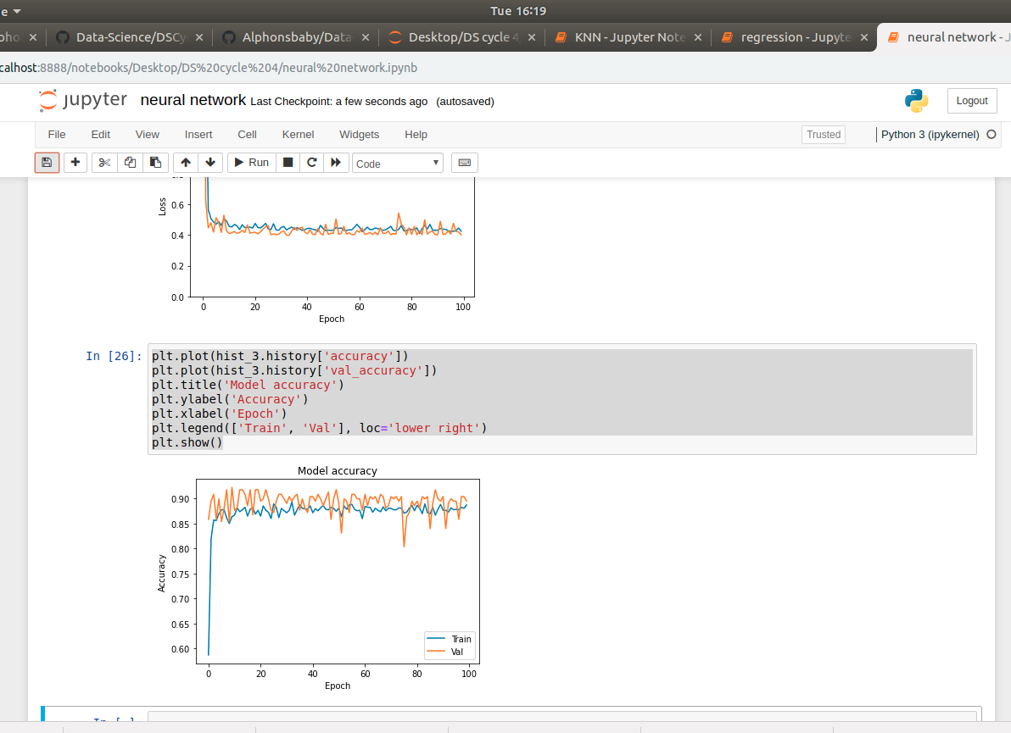

LAB CYCLE-5

LAB CYCLE 5-PART-1

1)Linear SVC The objective of a Linear SVC (Support Vector Classifier) is to fit to the data you provide, returning a "best fit" hyperplane that divides, or categorizes, your data. From there, after getting the hyperplane, you can then feed some features to your classifier to see what the "predicted" class is.
CountVectorizer:
Creates a matrix in which each unique word is represented by a column of the matrix, and each text sample from the document is a row in the matrix. The value of each cell is nothing but the count of the word in that particular text sample.

Given a data set of support tickets. Each ticket also has an associated "urgency score" of between 0 and 3, and where 0 is "very urgent" and 3 is "not urgent". It would be useful if we could have a machine guess how urgent a ticket is, based on the description, so the urgent tickets can be resolved first.
For the given data set, perform text classification using SVM and find out the accuracy of the model.

PROGRAM

from sklearn.feature_extraction.text import TfidfVectorizer, CountVectorizer

from sklearn.metrics import confusion_matrix
from sklearn.metrics import classification_report

from sklearn.model_selection import cross_val_score
from sklearn.model_selection import cross_val_predict
from sklearn.model_selection import train_test_split

from sklearn.svm import LinearSVC

with open("tickets.txt") as f:
tickets = f.read().strip().split("\n")

with open("labels_4.txt") as f:
labels = f.read().strip().split("\n")

X_train, X_test, y_train, y_test = train_test_split(tickets, labels, test_size=0.1, random_state=1337)

vectorizer = CountVectorizer()
svm = LinearSVC()
X_train = vectorizer.fit_transform(X_train)
X_test = vectorizer.transform(X_test)
_ = svm.fit(X_train, y_train)
y_pred = svm.predict(X_test)
print(classification_report(y_test, y_pred))

print(confusion_matrix(y_test, y_pred))

OUTPUT

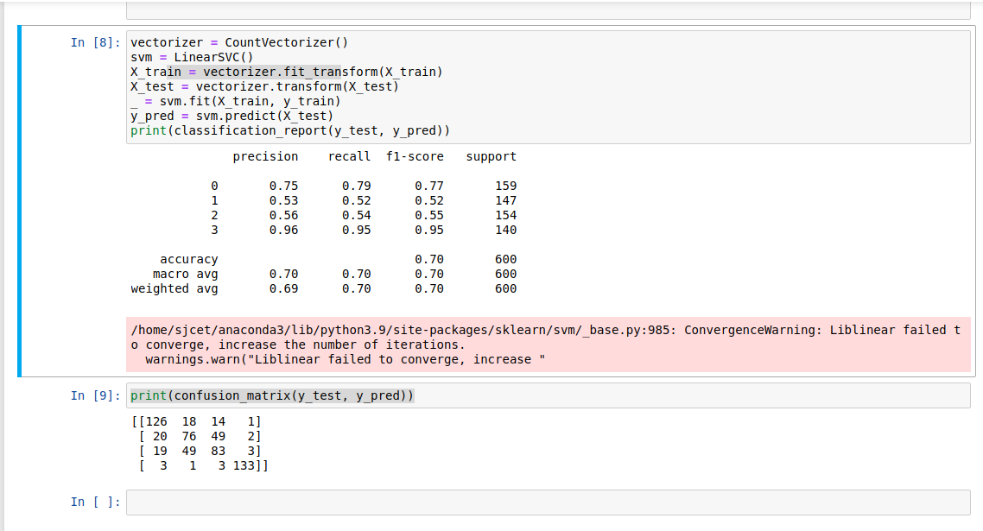

LAB CYCLE 5-PART-2
Given dataset contains 200 records and five columns, two of which describe the customer’s annual income and spending score. The latter is a value from 0 to 100. The higher the number, the more this customer has spent with the company in the past:
Functions to familiarize:
The purpose of Kmeans.fit() is to train the model with data.
The purpose of Kmeans.predict() is to apply a trained model to data
==================================================
Q. Using k means clustering create 6 clusters of customers based on their spending pattern.
- Visualize the same in a scatter plot with each cluster in a different color scheme.
- Display the cluster labels of each point.(print cluster indexes)
- Display the cluster centers.
- Use different values of K and visualize the same using scatter plot

PROGRAM
import pandas as pd
from sklearn.cluster import KMeans
import matplotlib.pyplot as plt
customers = pd.read_csv('customer_data.csv')
customers.head()

1)
kmeans = KMeans(n_clusters=6, random_state=0)
kmeans.fit(points)
predicted_cluster_indexes = kmeans.predict(points)
plt.scatter(x, y, c=predicted_cluster_indexes, s=50, alpha=0.7, cmap='viridis')
plt.xlabel('Annual Income (k$)')
plt.ylabel('Spending Score')

OUTPUT
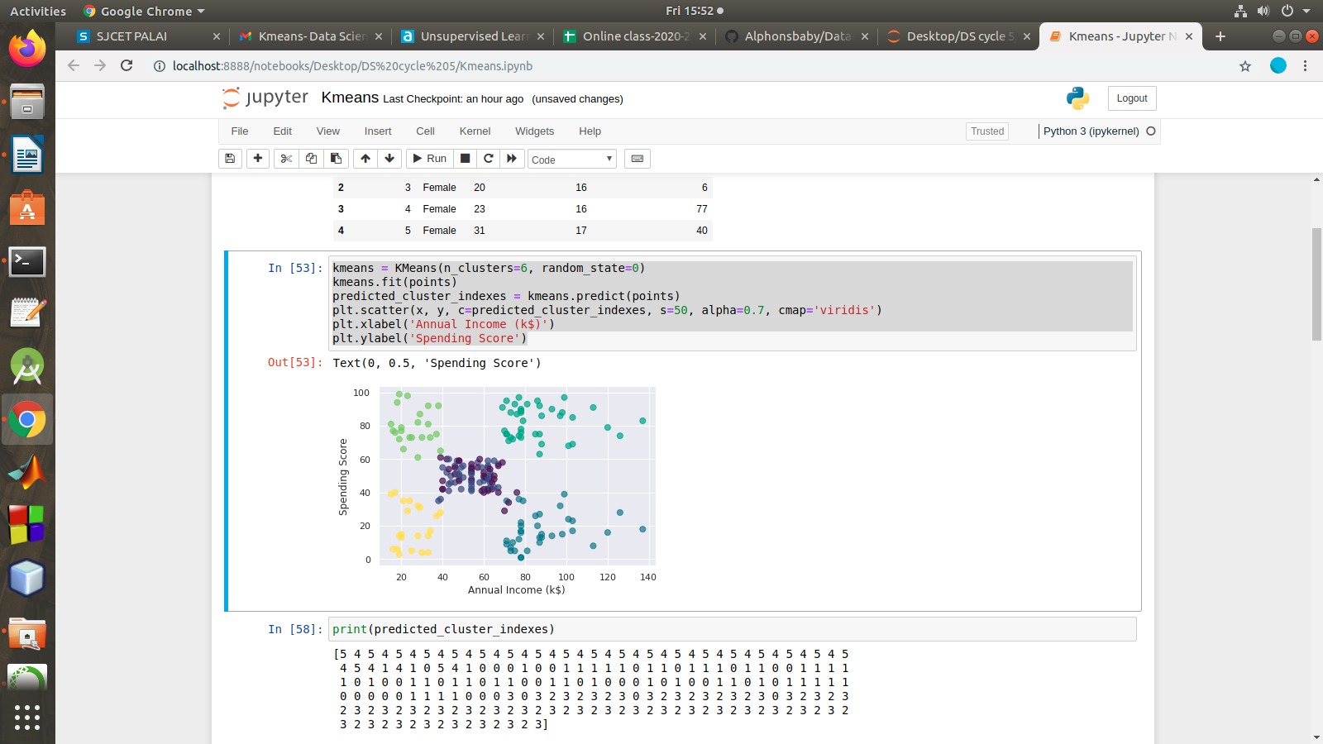

2)
print(predicted_cluster_indexes)

OUTPUT
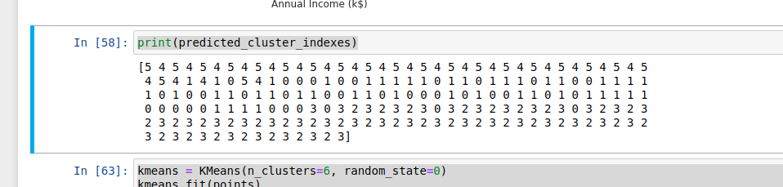
3)
kmeans = KMeans(n_clusters=6, random_state=0)
kmeans.fit(points)
predicted_cluster_indexes = kmeans.predict(points)
plt.scatter(x, y, c=predicted_cluster_indexes, s=50, alpha=0.7, cmap='viridis')
plt.xlabel('Annual Income (k$)')
plt.ylabel('Spending Score')
centers = kmeans.cluster_centers_
plt.scatter(centers[:, 0], centers[:, 1], c='red', s=100)

OUTPUT
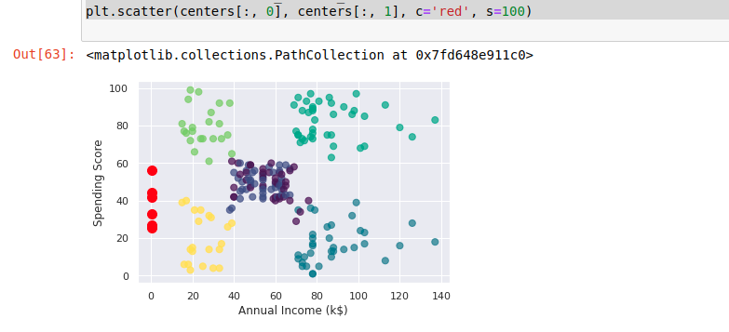

4)
kmeans = KMeans(n_clusters=4, random_state=0)
kmeans.fit(points)
predicted_cluster_indexes = kmeans.predict(points)
plt.scatter(x, y, c=predicted_cluster_indexes, s=50, alpha=0.7, cmap='viridis')
centers = kmeans.cluster_centers_
plt.scatter(centers[:, 0], centers[:, 1], c='red', s=100)

OUTPUT
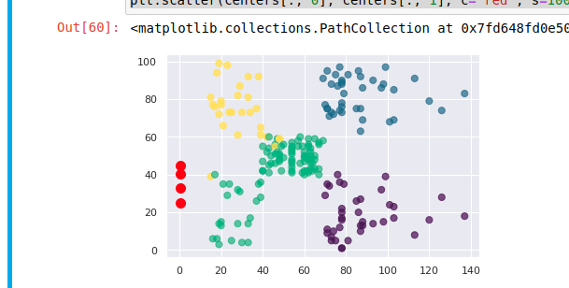

LAB CYCLE 5 PART -3

Q. Using NLP
- find out words in the sentance
- Print the tokenization
- Find the N-gram
program

from nltk.corpus import stopwords
import nltk
from nltk.tokenize import sent_tokenize,word_tokenize
text1 = "The data set given satisfies the requirement for model generation. This is used in Data Science Lab"
print(sent_tokenize(text1))
print(word_tokenize(text1))

Output
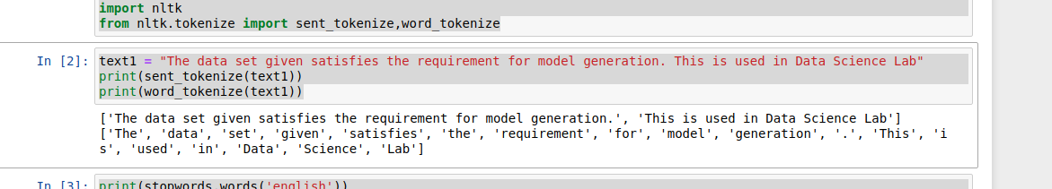

2)
print(stopwords.words('english'))
text = word_tokenize(text1)
text= [word for word in text if word not in stopwords.words('english')]
print(text)
print(nltk.pos_tag(text))
Output
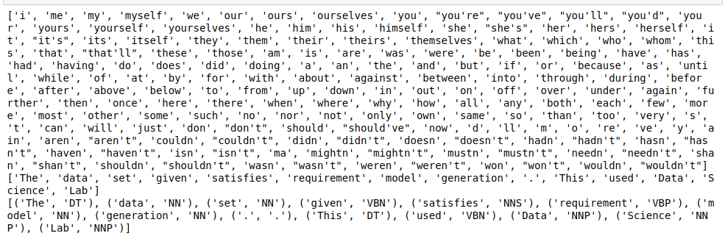

3)
temp=zip(*[text[i:] for i in range(0,2)])
ans=[' '.join(ngram) for ngram in temp]
print(ans)
temp=zip(*[text[i:] for i in range(0,4)])
ans=[' '.join(ngram) for ngram in temp]
print(ans)

Output

